# การวิเคราะห์การใช้ไฟฟ้า

รายงานนี้ประกอบด้วยการวิเคราะห์พฤติกรรมการใช้ไฟฟ้าและการติดตั้งโซล่าเซลล์.

## Images from Result

Image: anual_load.png

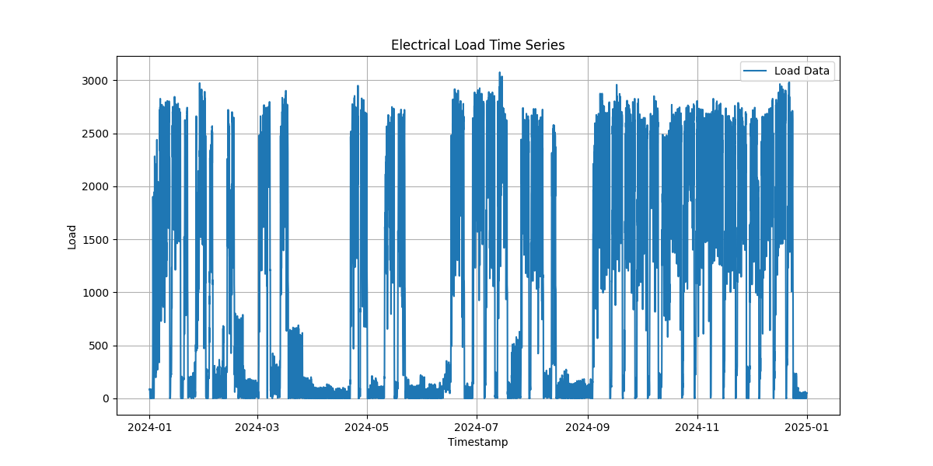

Image: average_load_every_day.png

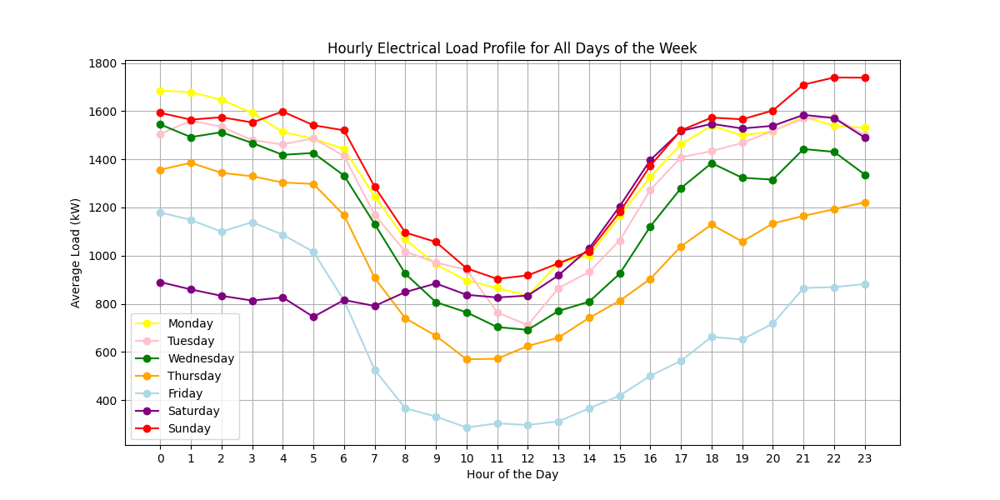

Image: average_weekday_weekend.png

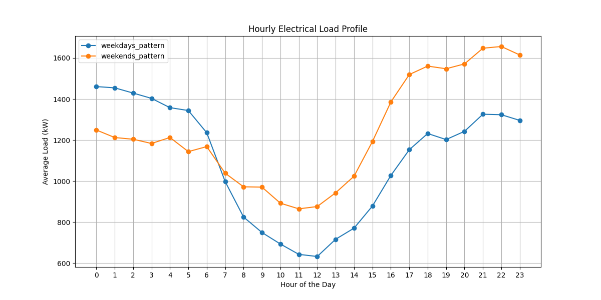

Image: LoadVariation.png

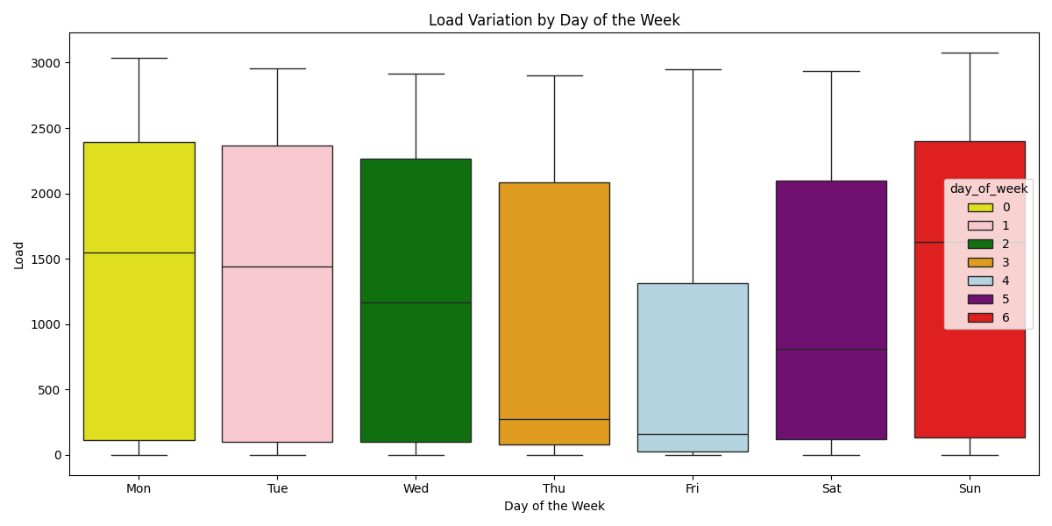

Image: Load_and_PV(1,000_kWp)_10_October.png

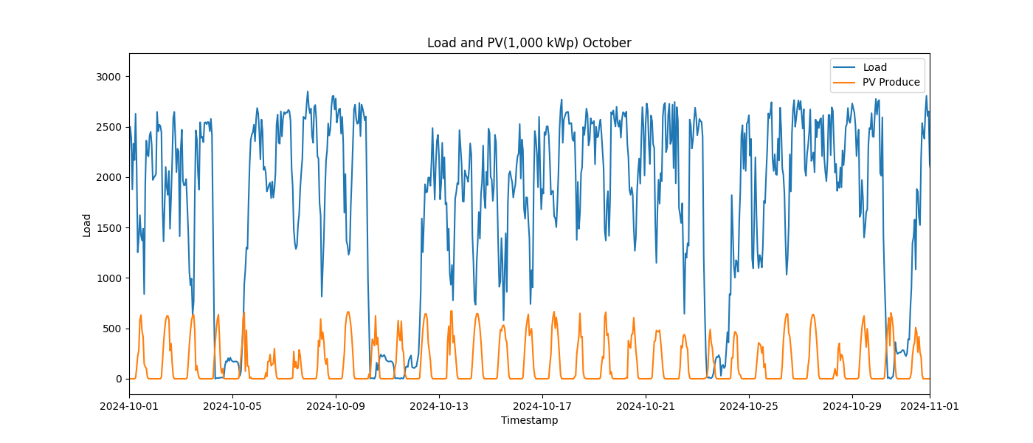

Image: Load_and_PV(1,000_kWp)_11_November.png

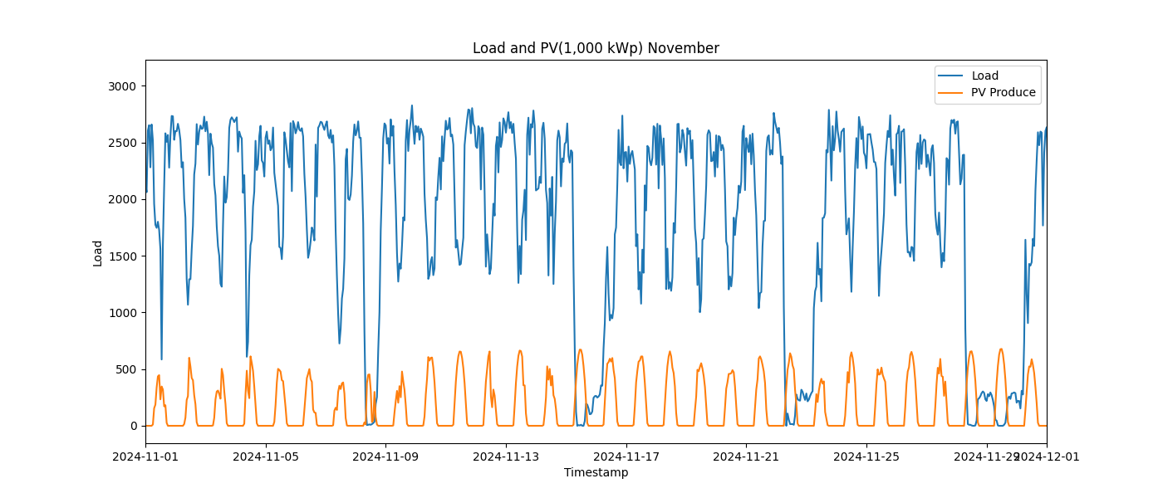

Image: Load_and_PV(1,000_kWp)_12_December.png

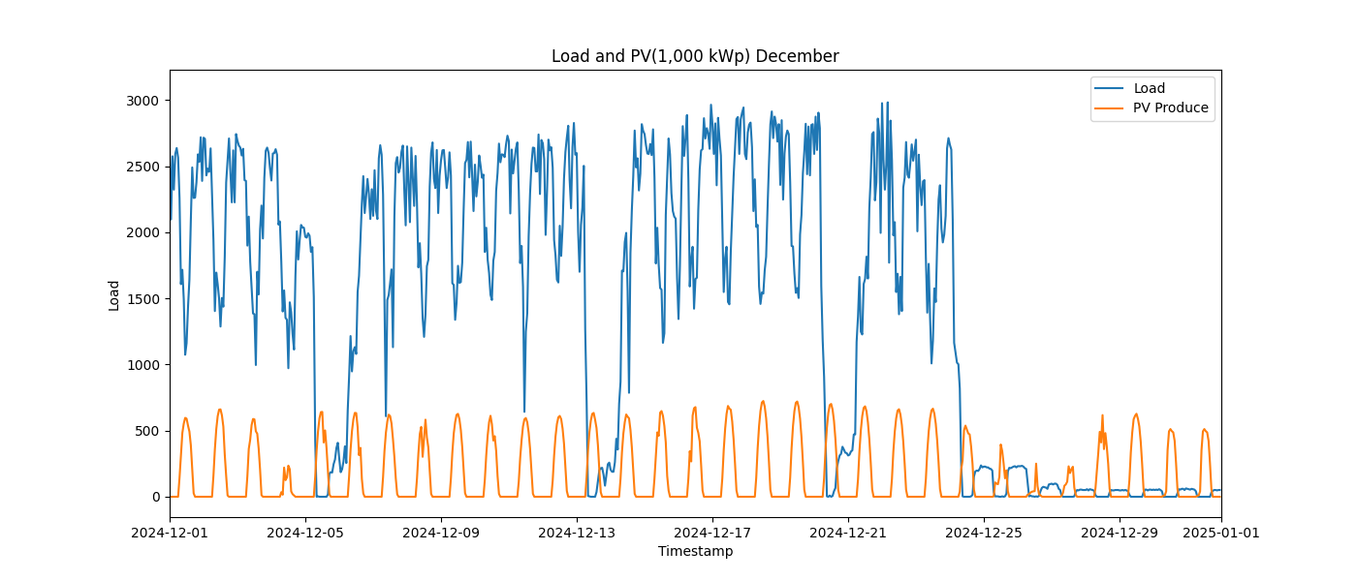

Image: Load_and_PV(1,000_kWp)_1_January.png

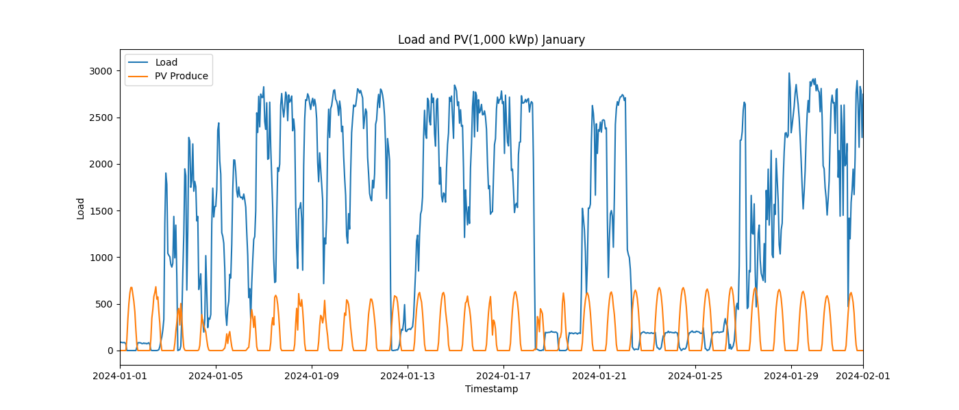

Image: Load_and_PV(1,000_kWp)_2_February.png

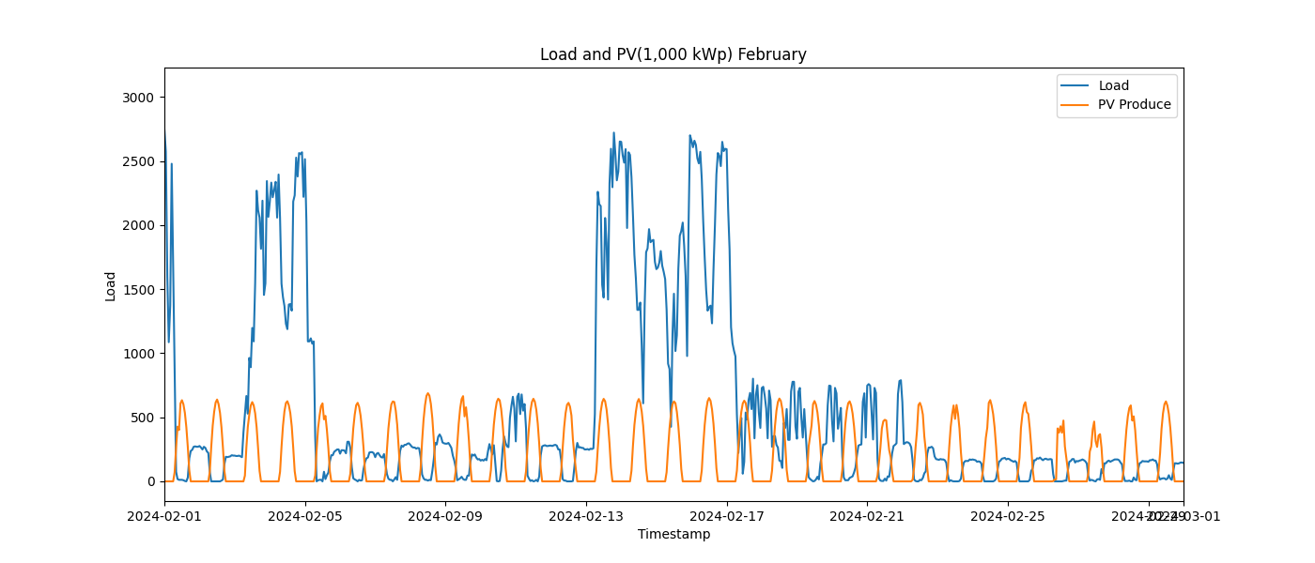

Image: Load_and_PV(1,000_kWp)_3_March.png

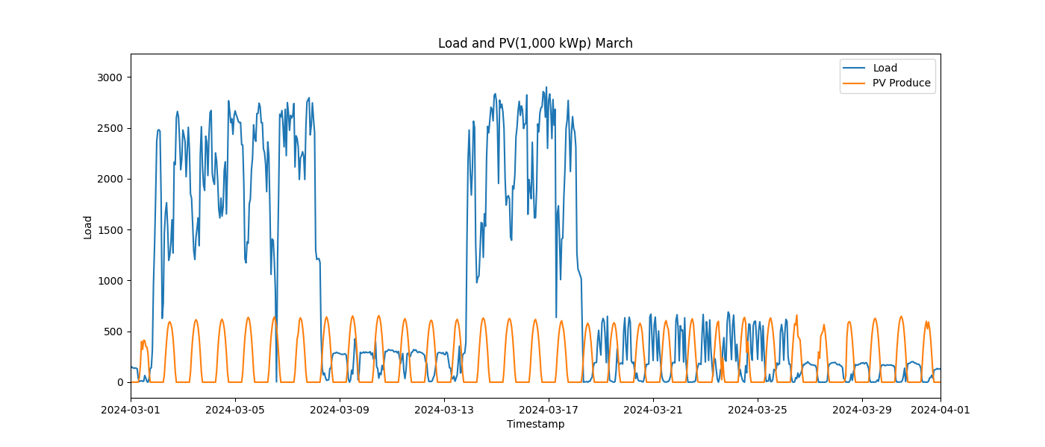

Image: Load_and_PV(1,000_kWp)_4_April.png

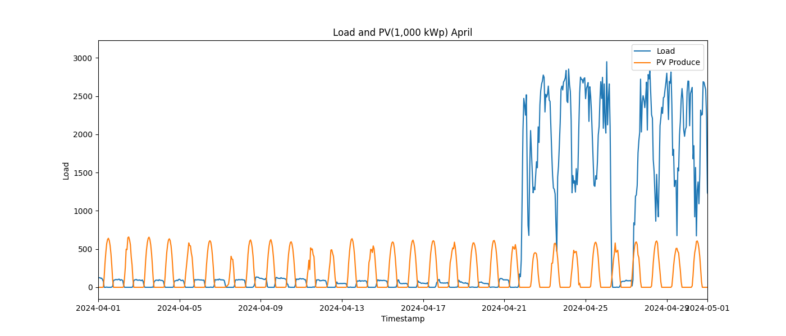

Image: Load_and_PV(1,000_kWp)_5_May.png

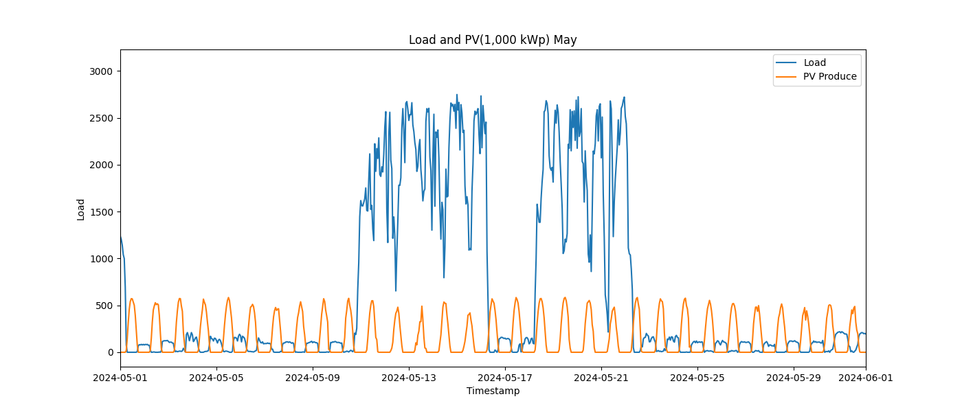

Image: Load_and_PV(1,000_kWp)_6_June.png

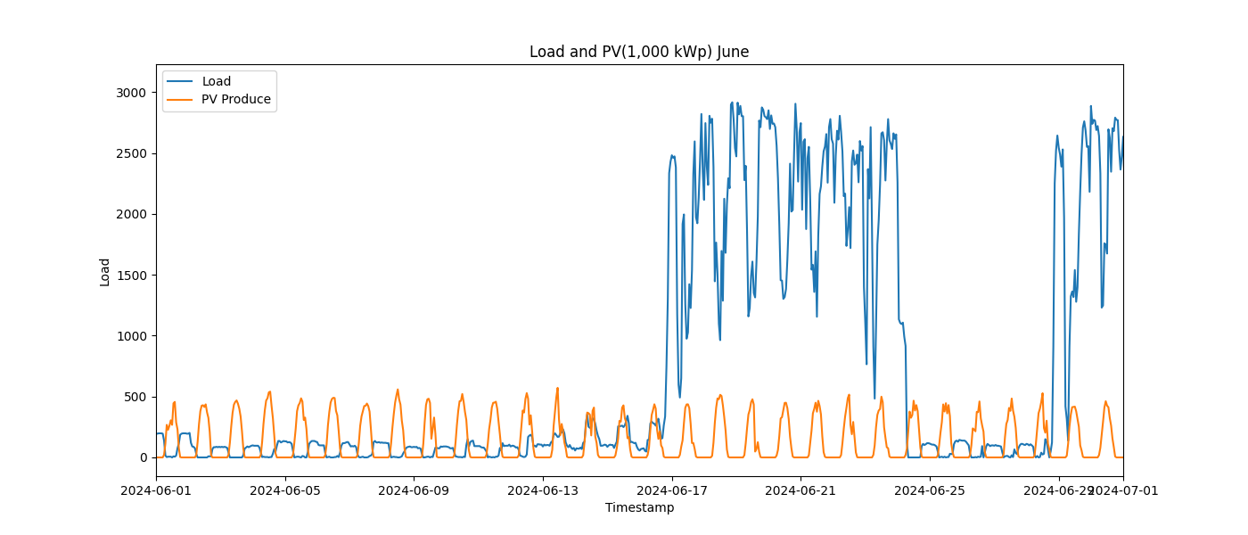

Image: Load_and_PV(1,000_kWp)_7_July.png

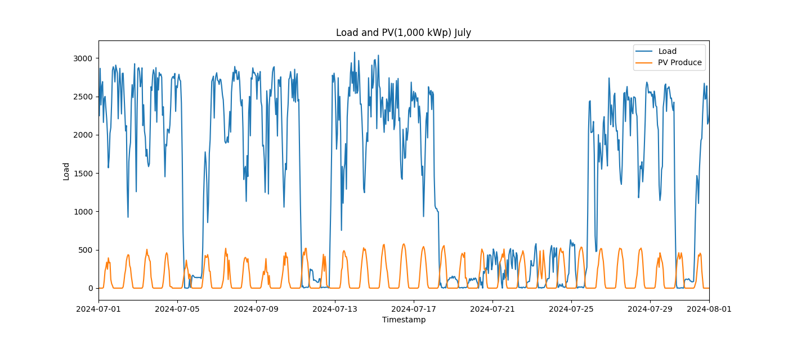

Image: Load_and_PV(1,000_kWp)_8_August.png

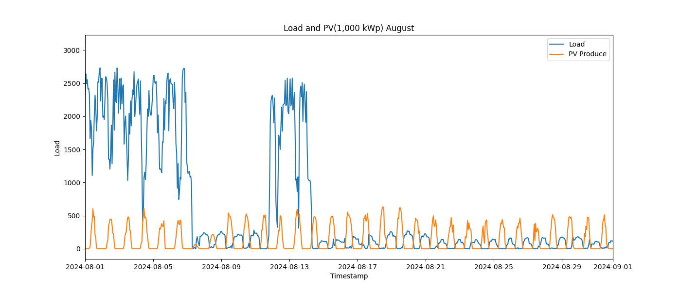

Image: Load_and_PV(1,000_kWp)_9_September.png

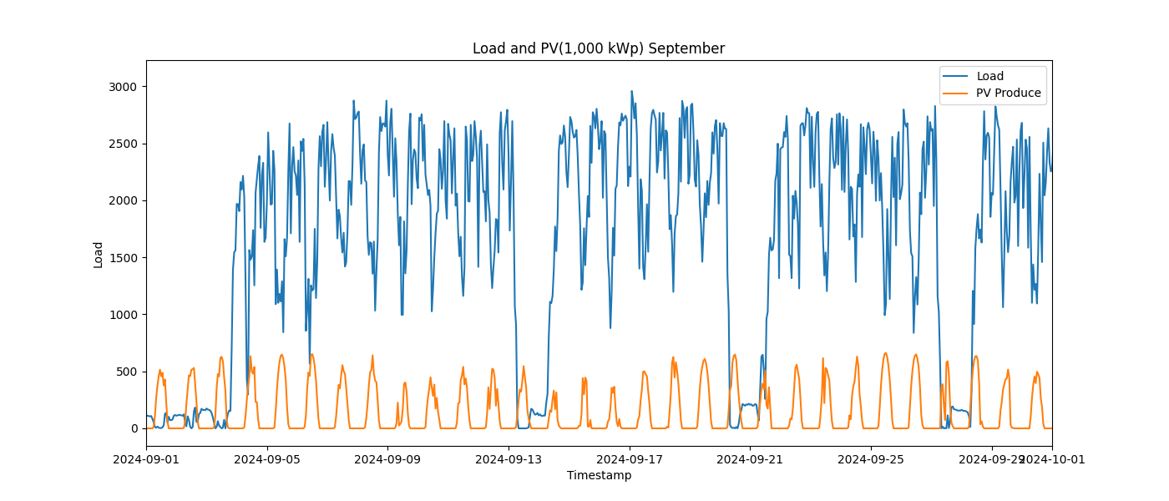

Image: Load_and_PV(100_kWp)_10_October.png

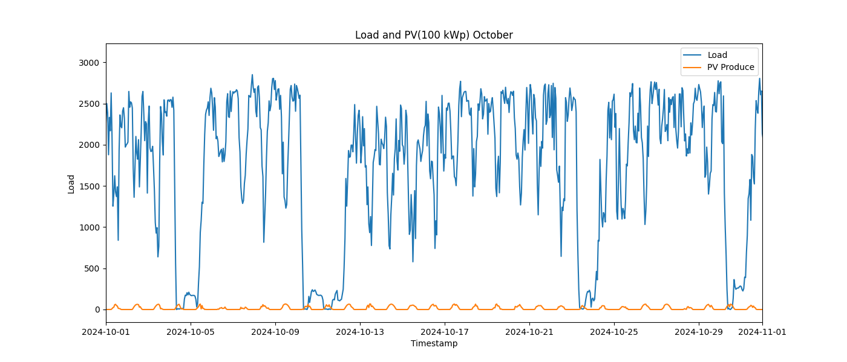

Image: Load_and_PV(100_kWp)_11_November.png

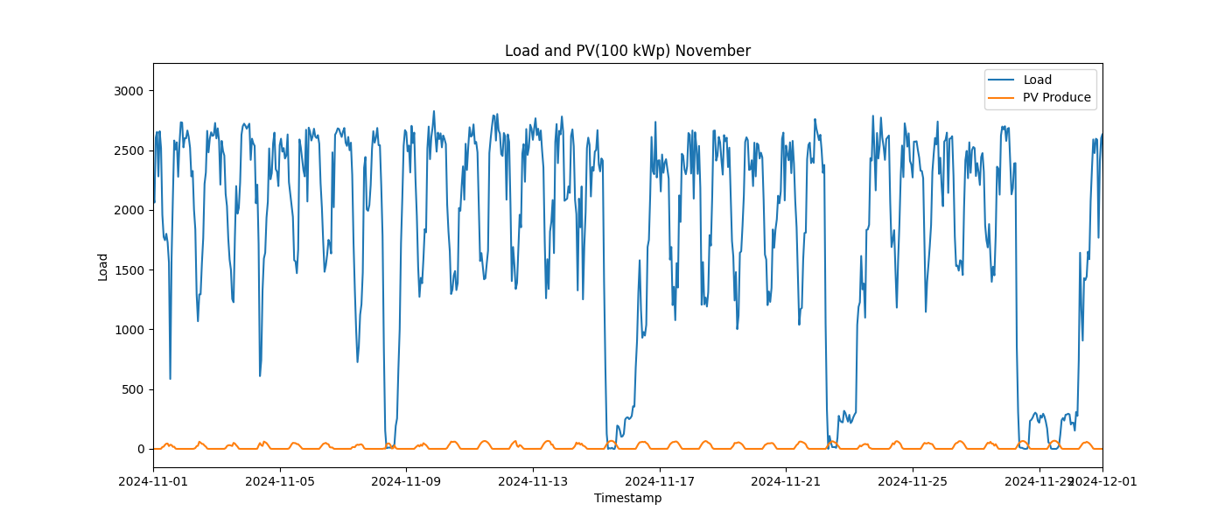

Image: Load_and_PV(100_kWp)_12_December.png

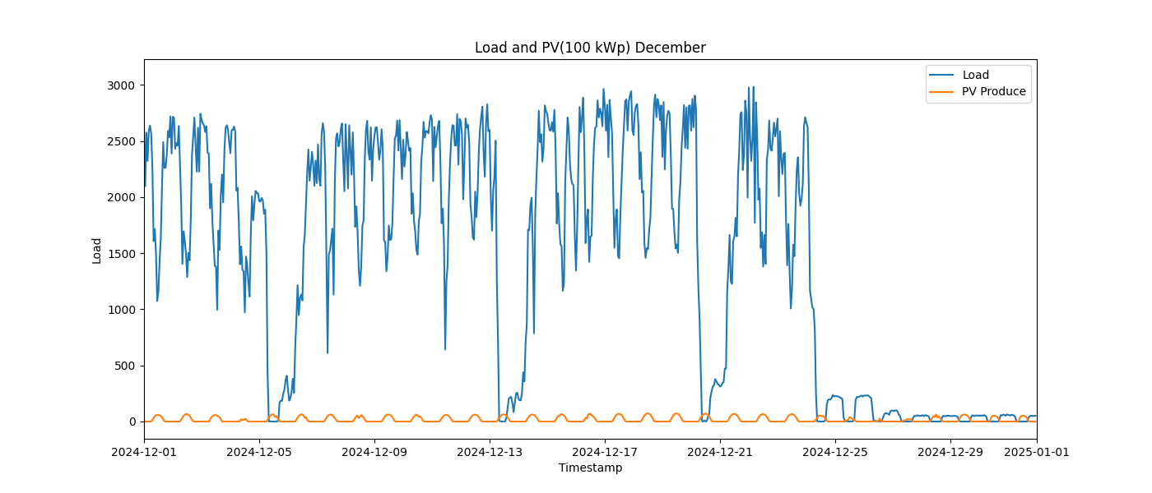

Image: Load_and_PV(100_kWp)_1_January.png

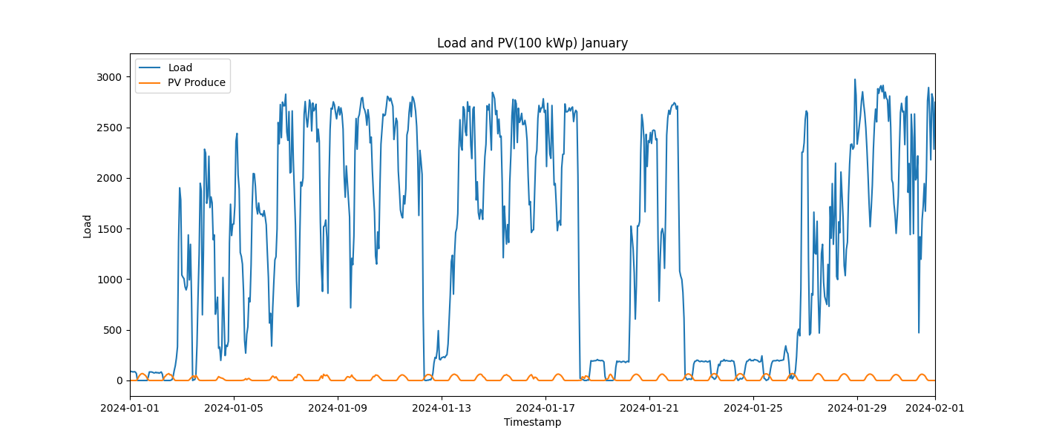

Image: Load_and_PV(100_kWp)_2_February.png

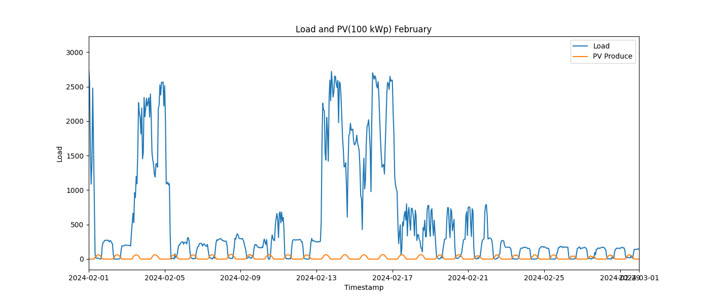

Image: Load_and_PV(100_kWp)_3_March.png

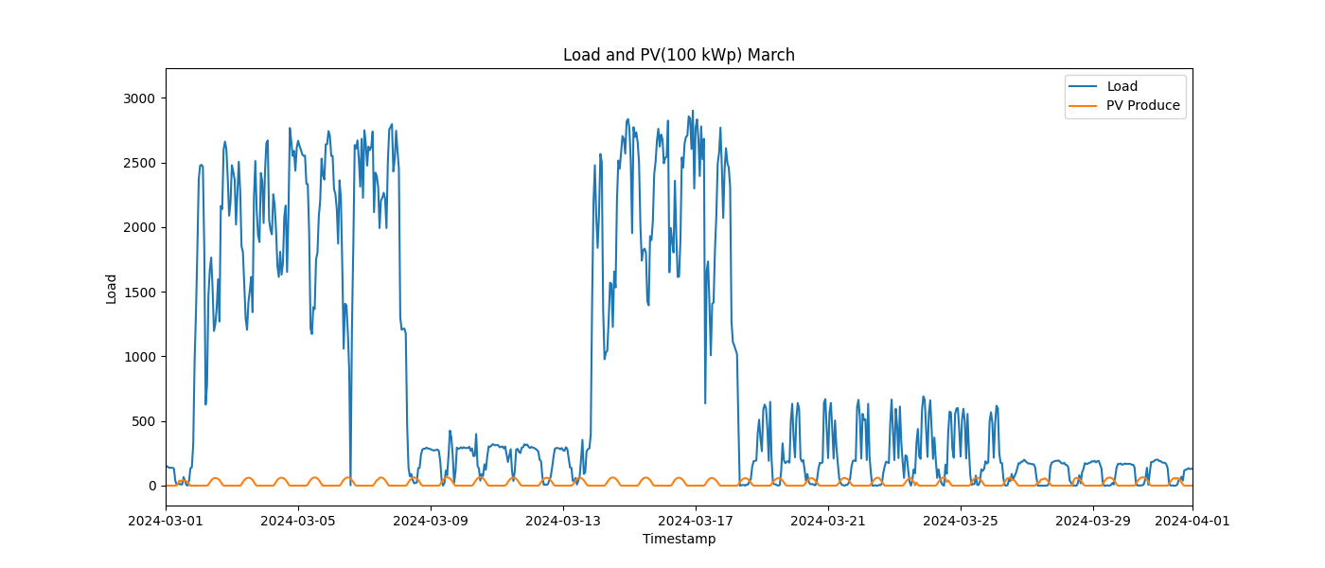

Image: Load_and_PV(100_kWp)_4_April.png

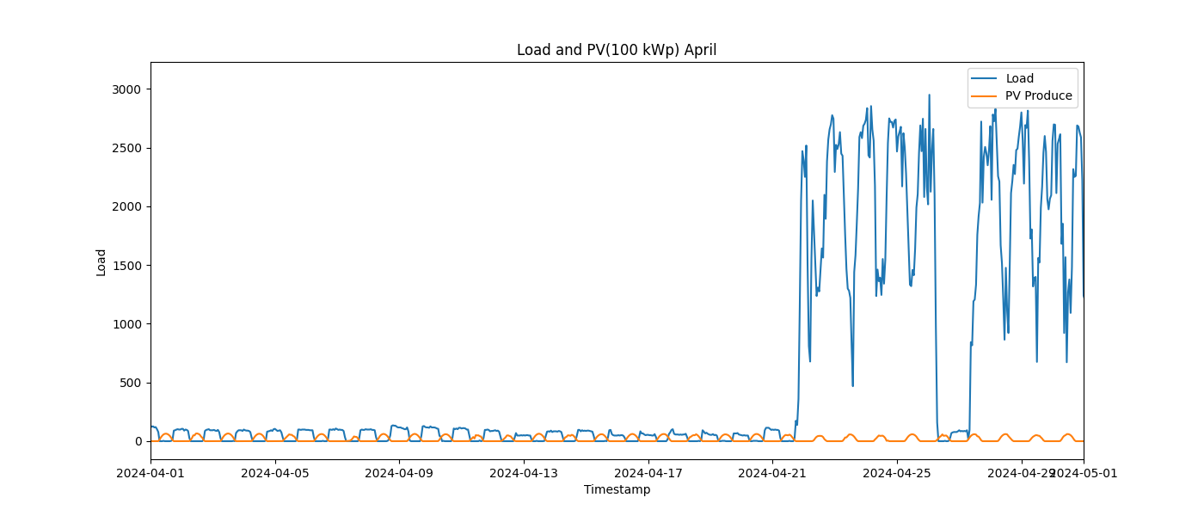

Image: Load_and_PV(100_kWp)_5_May.png

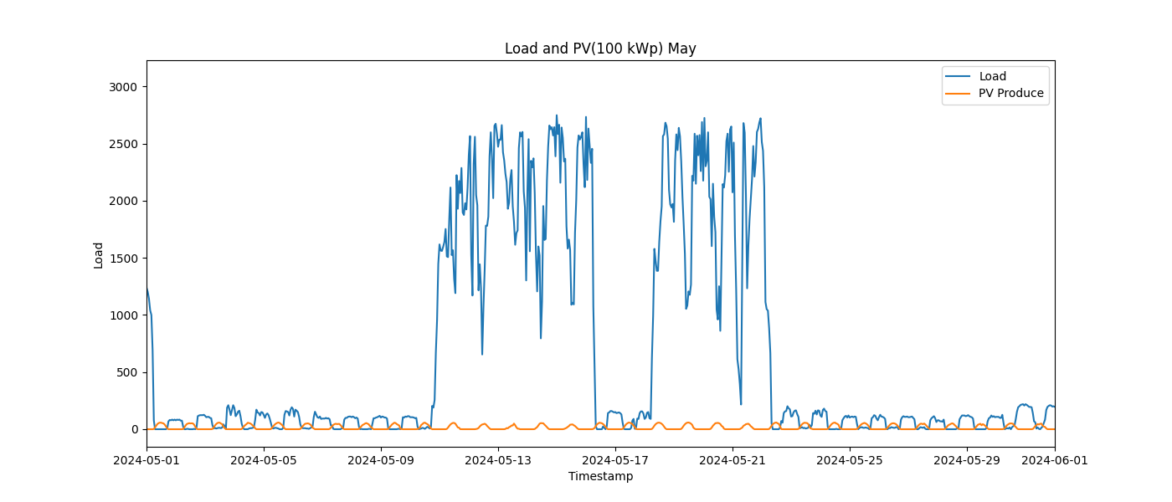

Image: Load_and_PV(100_kWp)_6_June.png

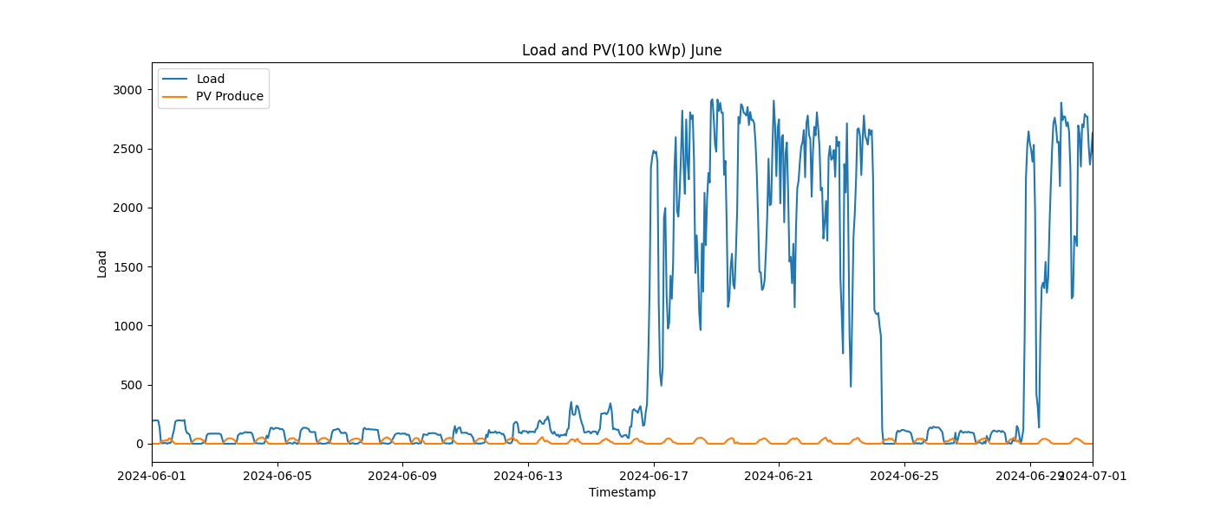

Image: Load_and_PV(100_kWp)_7_July.png

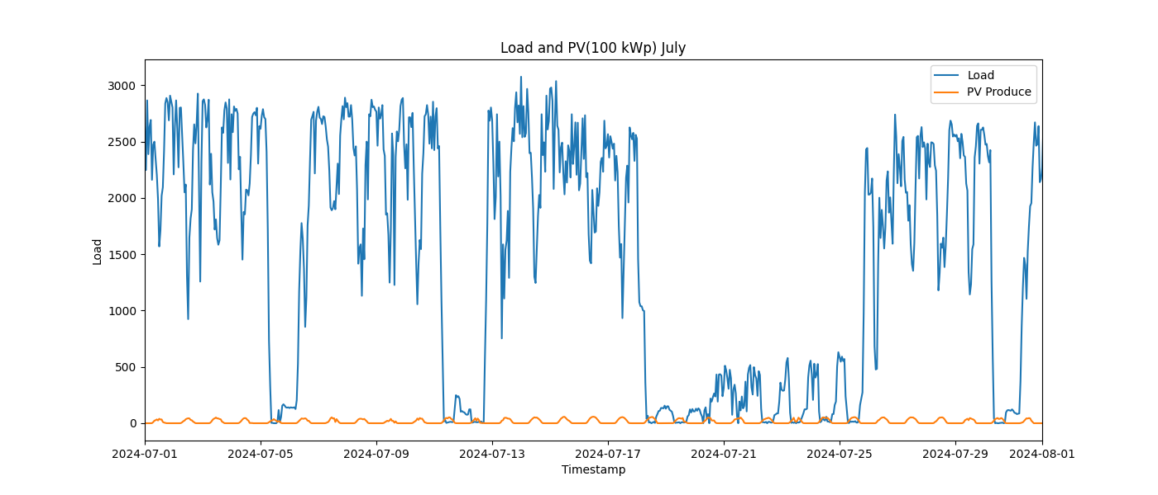

Image: Load_and_PV(100_kWp)_8_August.png

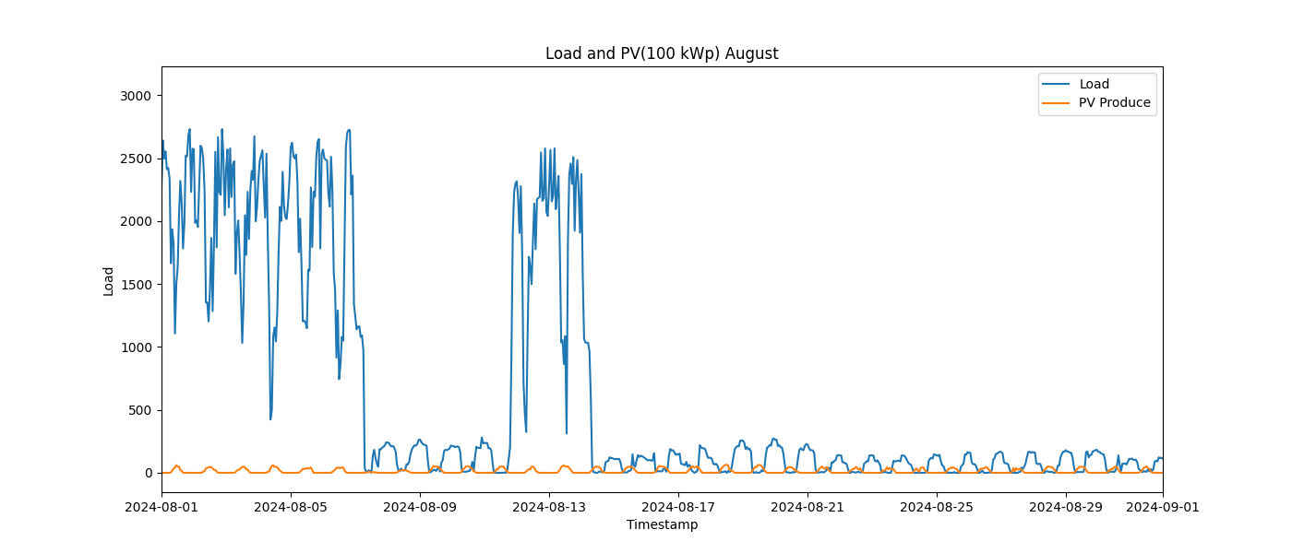

Image: Load_and_PV(100_kWp)_9_September.png

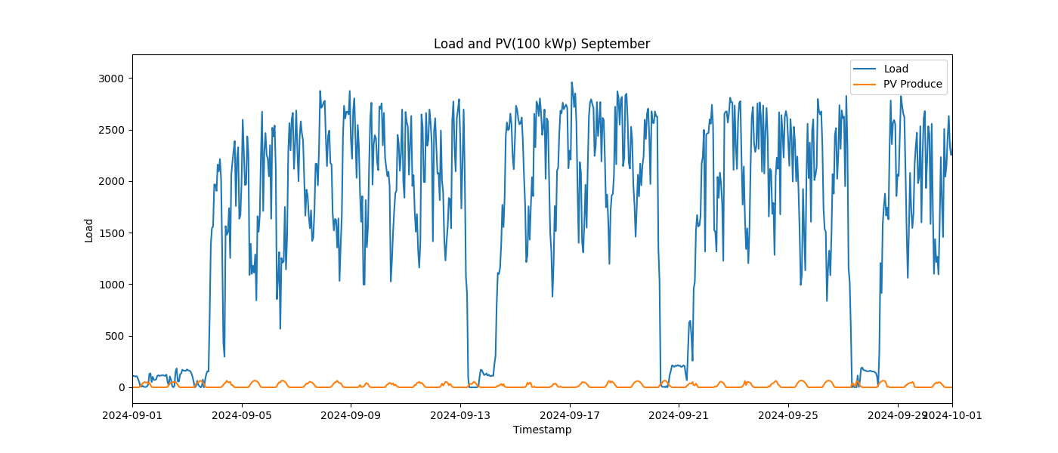

Image: Load_and_PV(500_kWp)_10_October.png

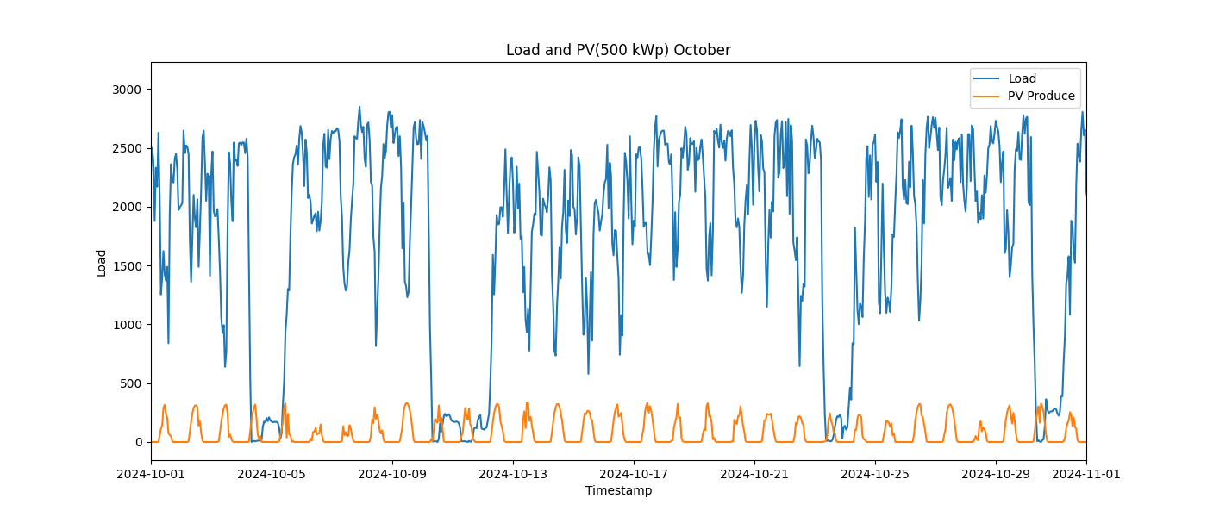

Image: Load_and_PV(500_kWp)_11_November.png

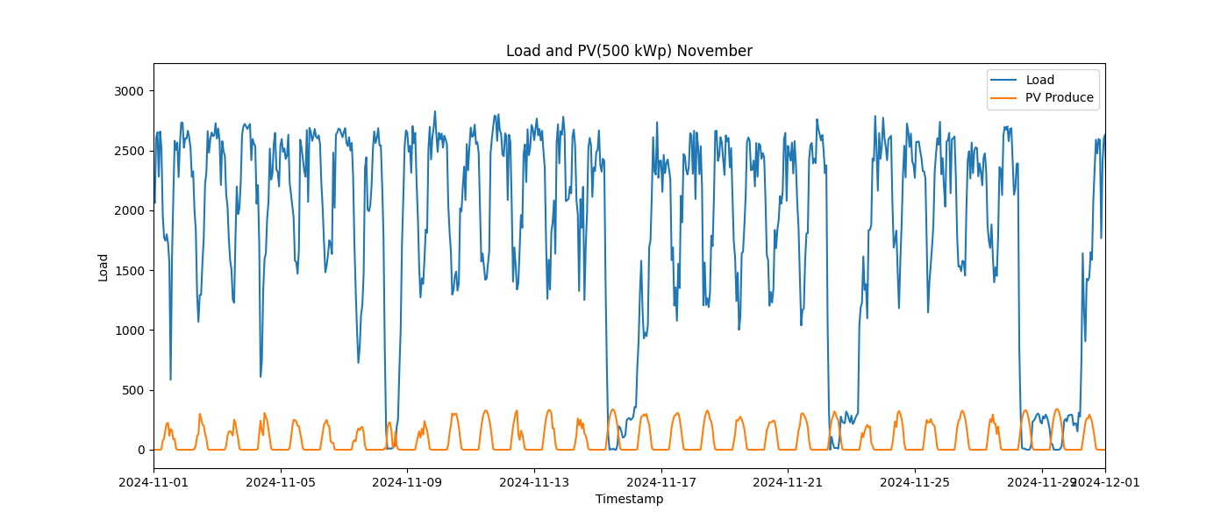

Image: Load_and_PV(500_kWp)_12_December.png

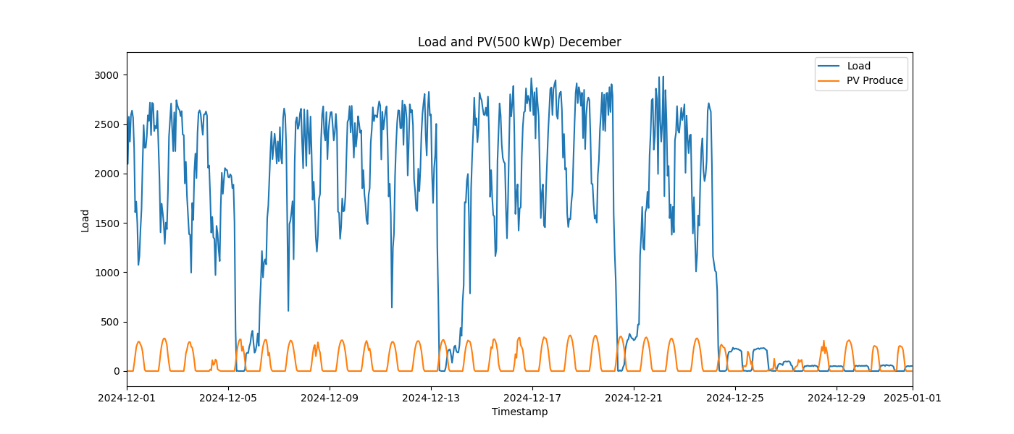

Image: Load_and_PV(500_kWp)_1_January.png

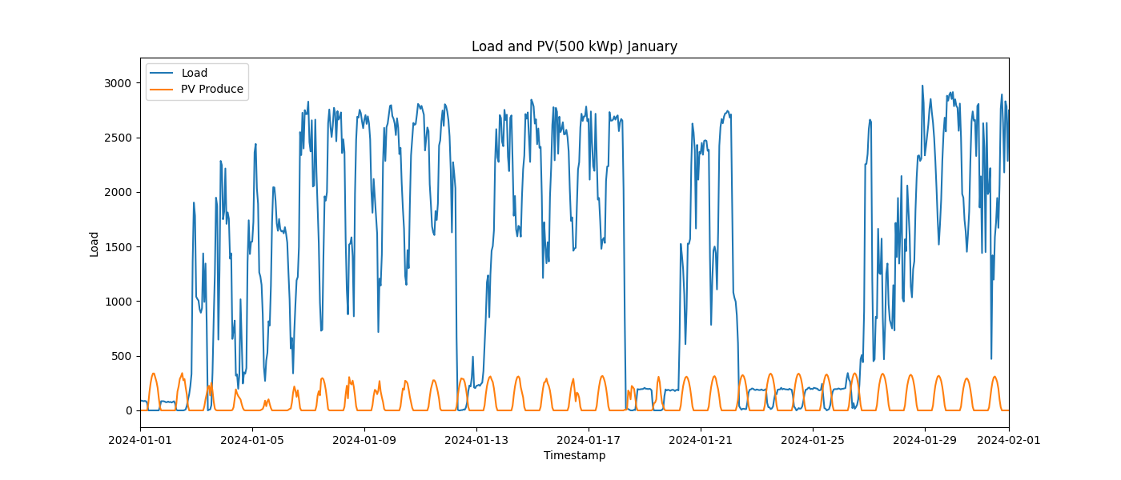

Image: Load_and_PV(500_kWp)_2_February.png

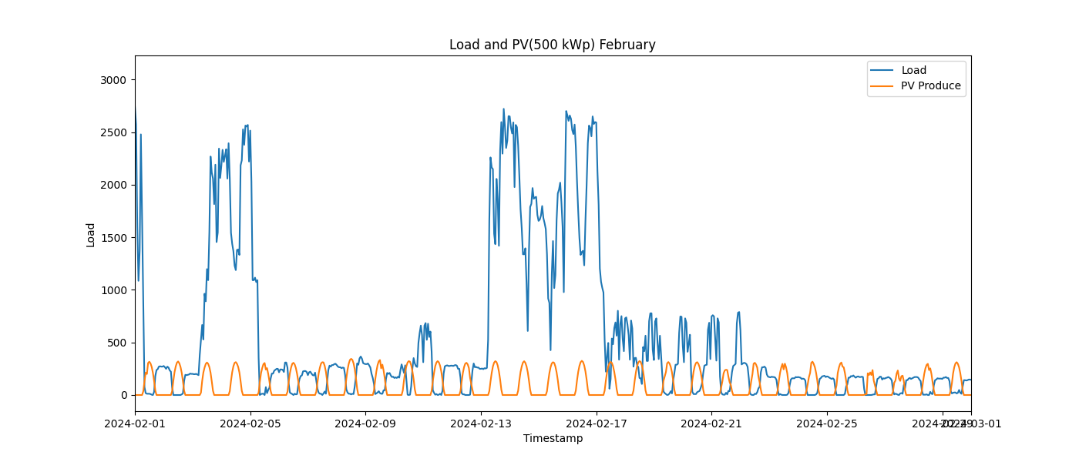

Image: Load_and_PV(500_kWp)_3_March.png

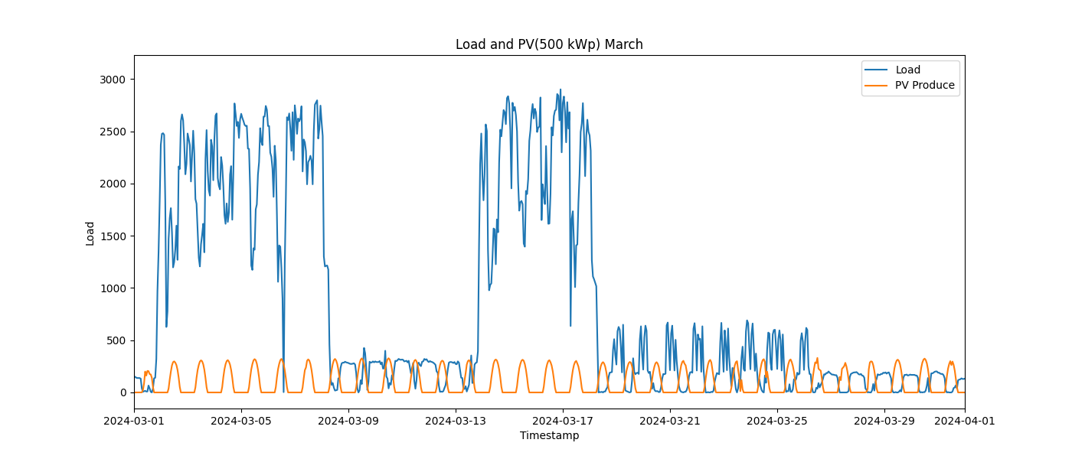

Image: Load_and_PV(500_kWp)_4_April.png

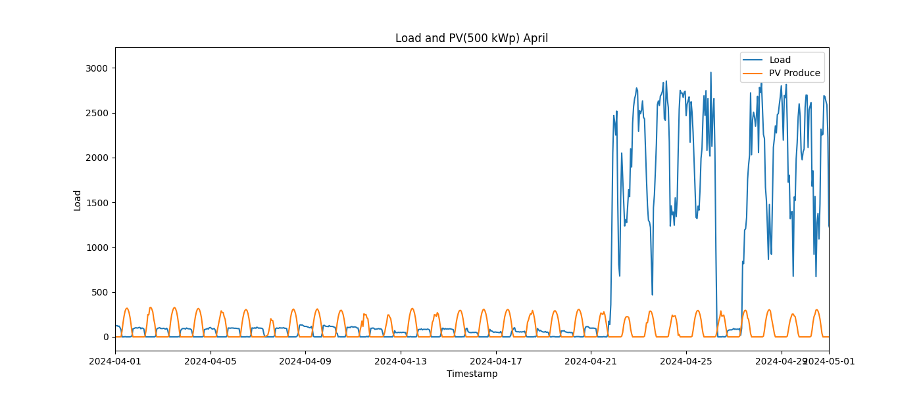

Image: Load_and_PV(500_kWp)_5_May.png

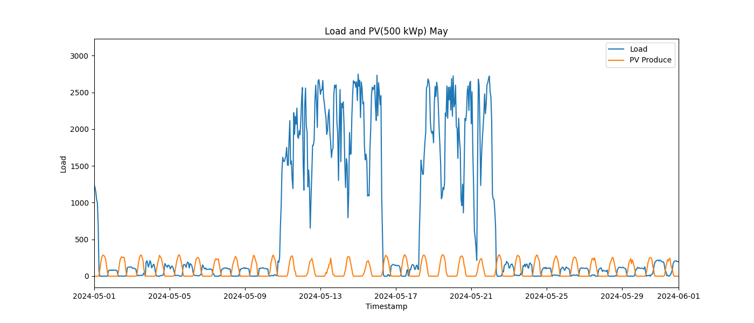

Image: Load_and_PV(500_kWp)_6_June.png

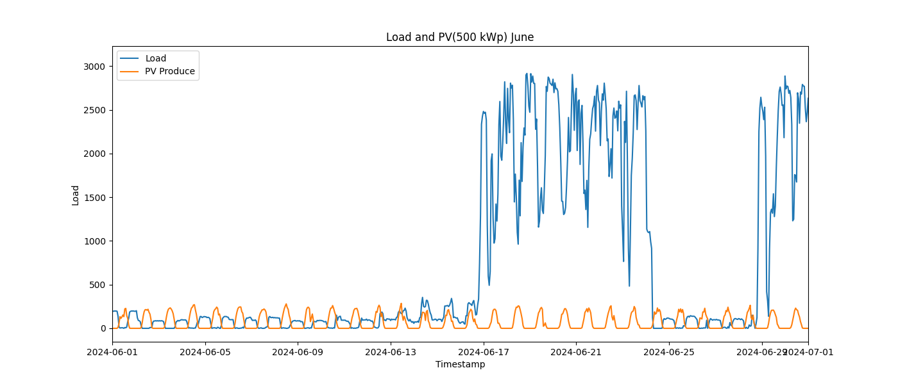

Image: Load_and_PV(500_kWp)_7_July.png

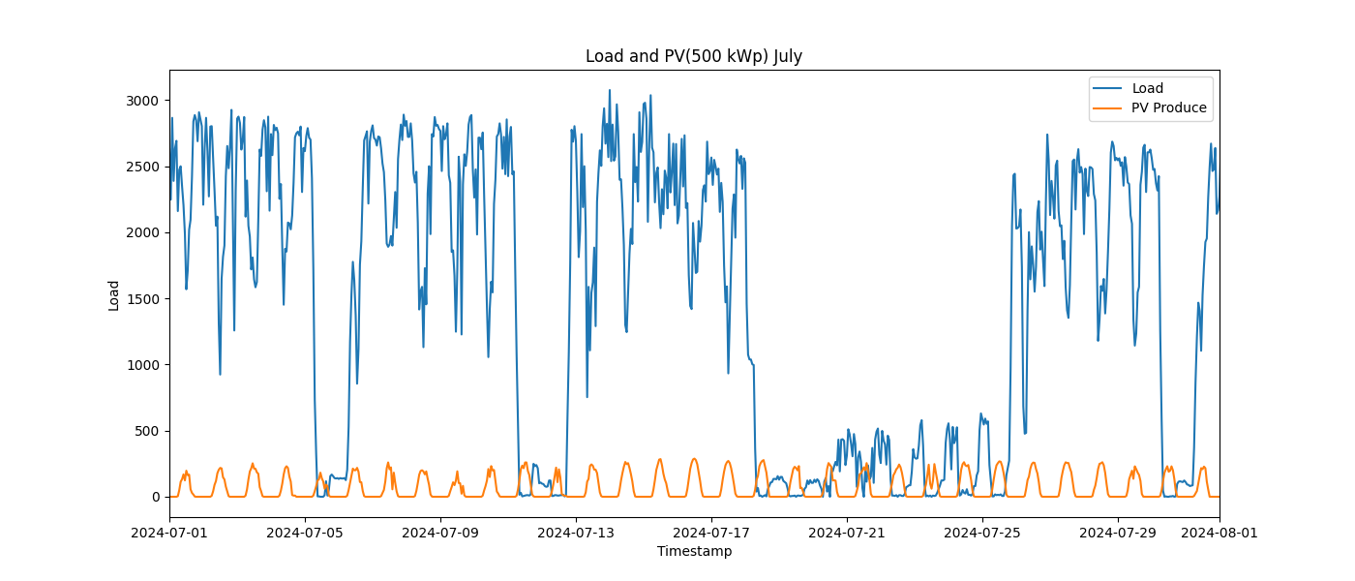

Image: Load_and_PV(500_kWp)_8_August.png

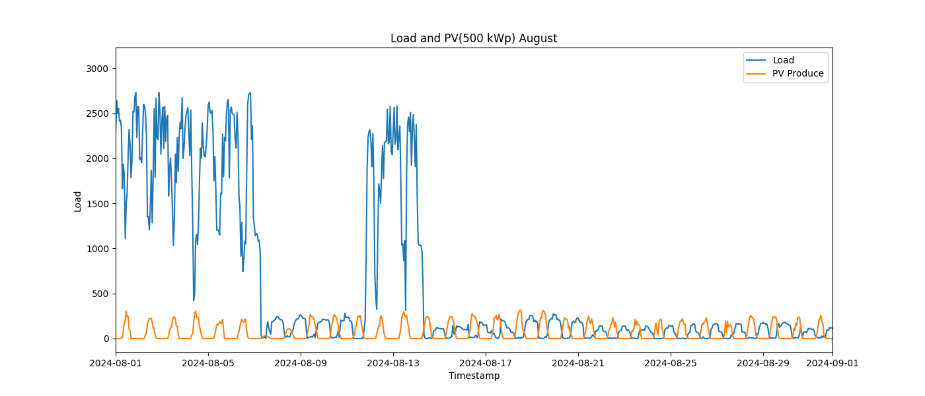

Image: Load_and_PV(500_kWp)_9_September.png

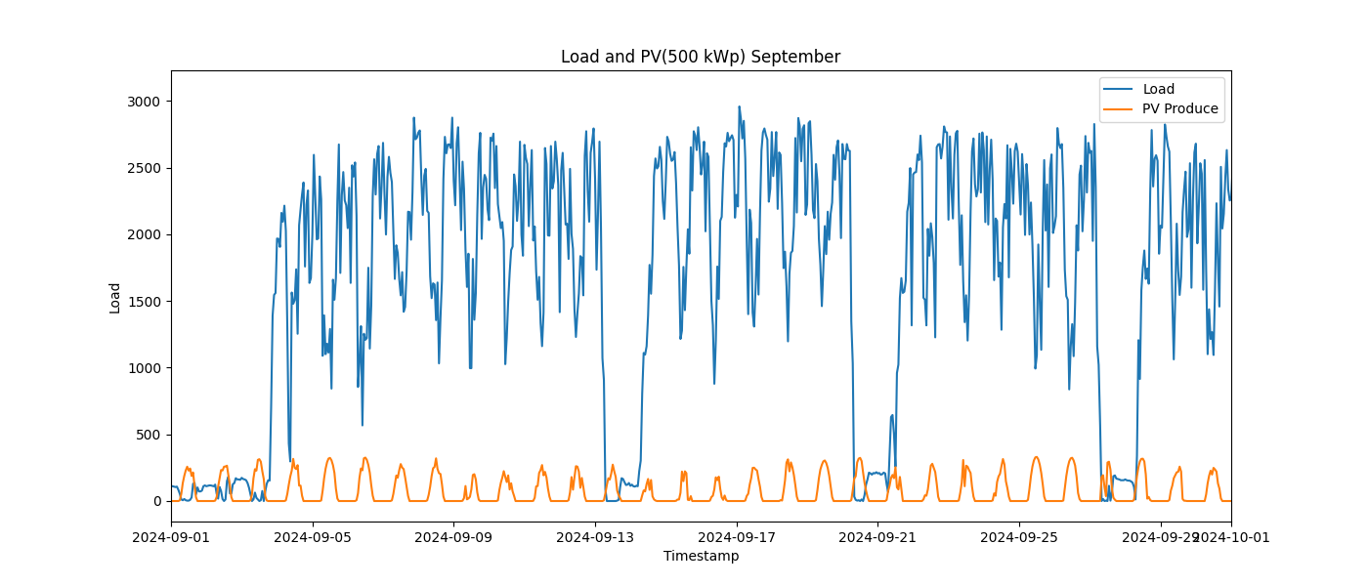

Image: load_distribution.png

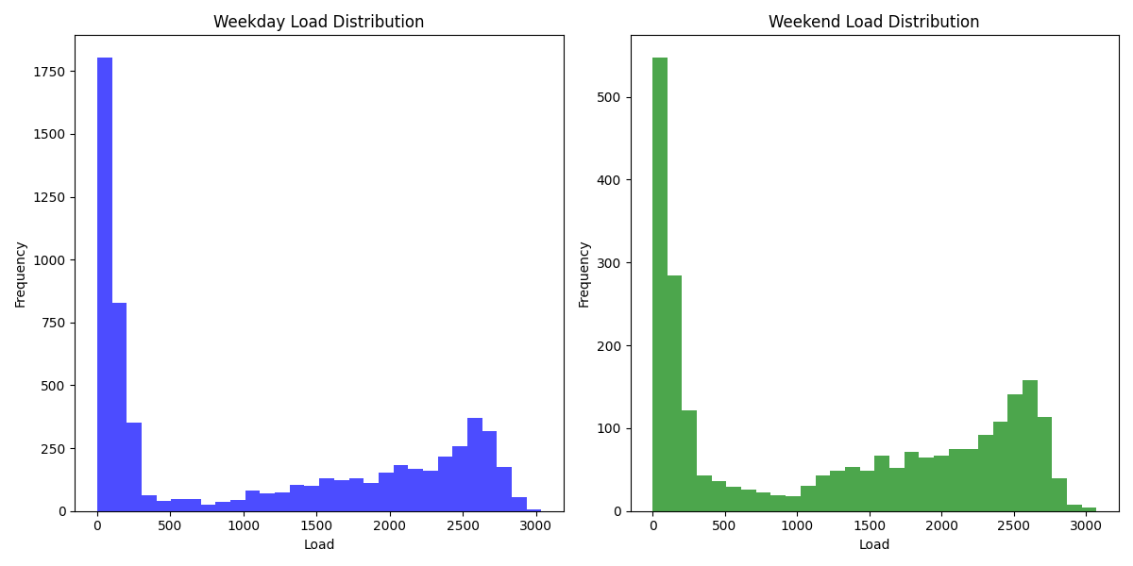

Image: load_duration_curve_all_days.png

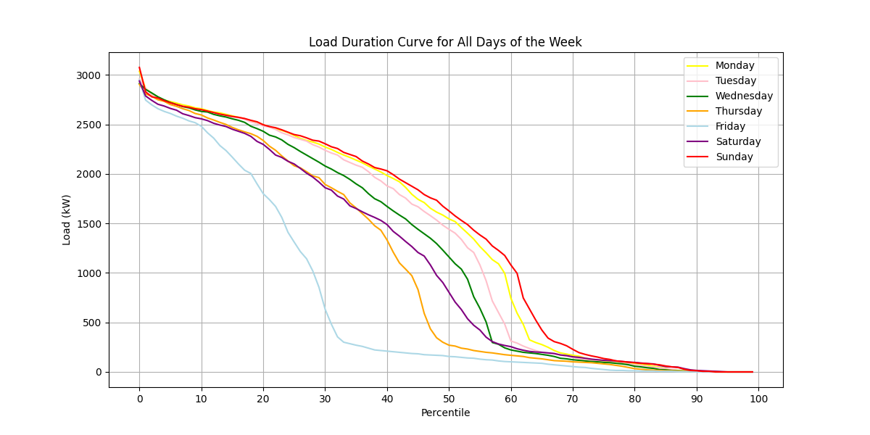

Image: load_duration_curve_all_months.png

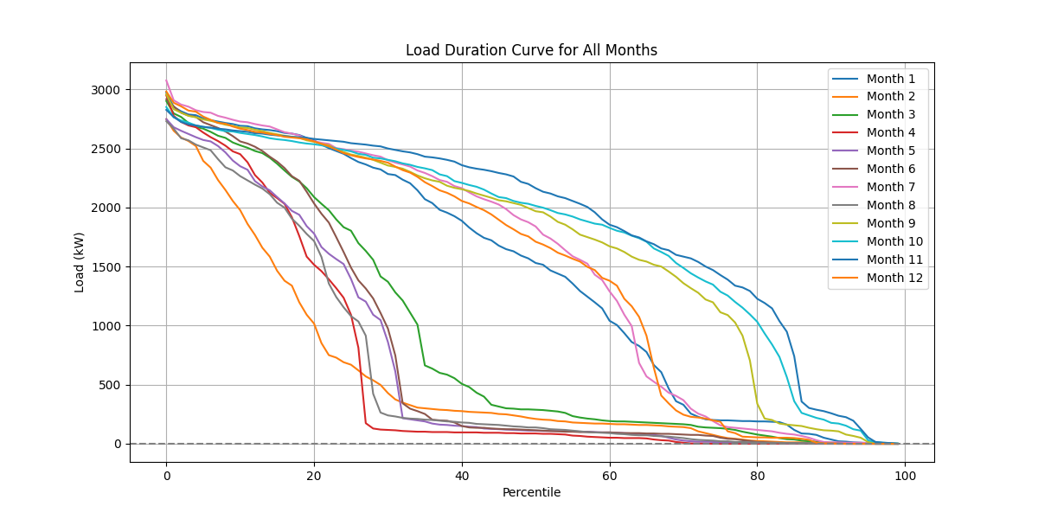

Image: load_duration_curve_weekdays_weekends.png

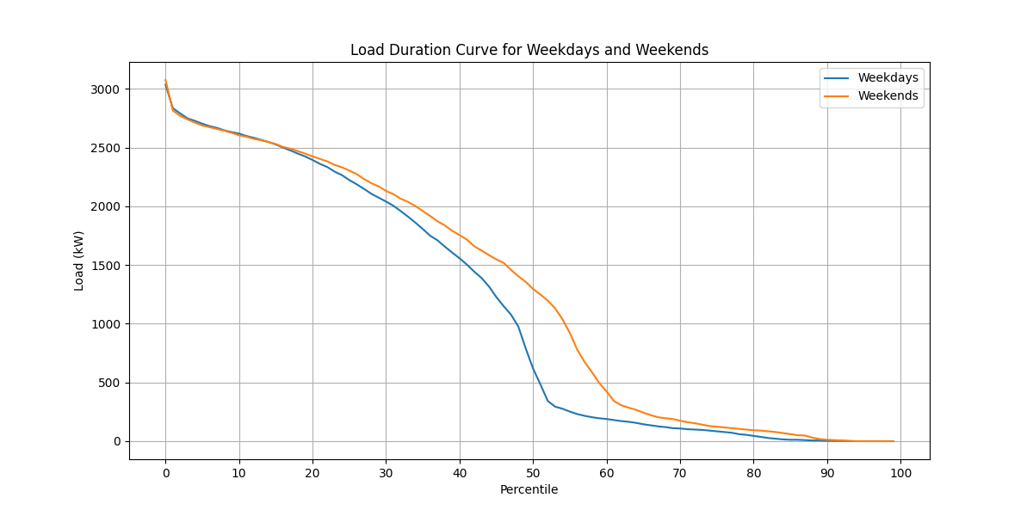

Image: load_pv(1,000_kWp).png

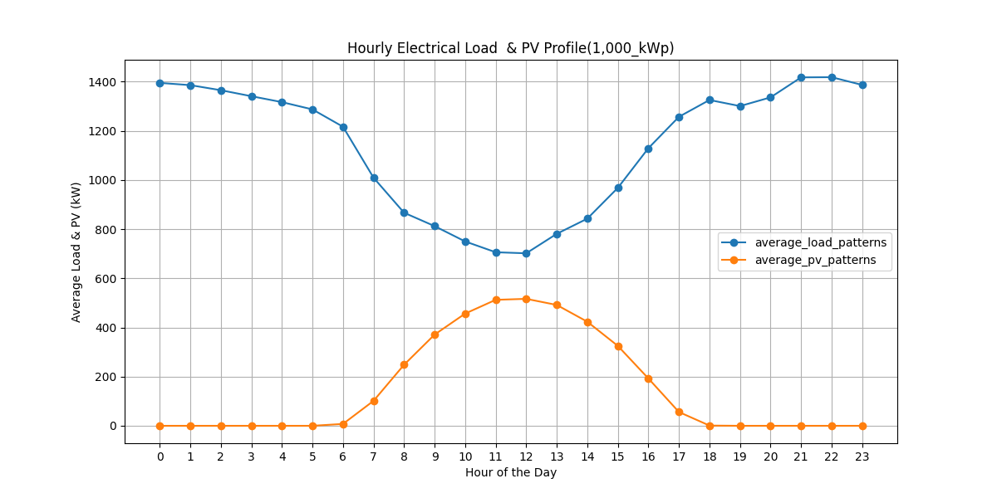

Image: load_pv(100_kWp).png

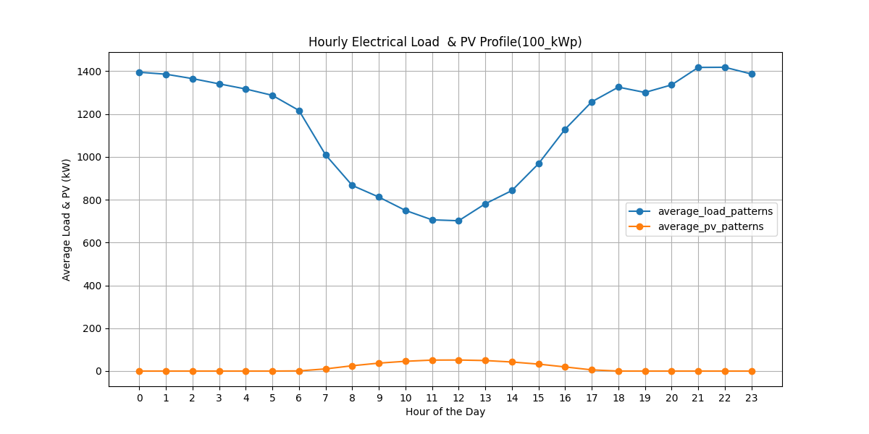

Image: load_pv(500_kWp).png

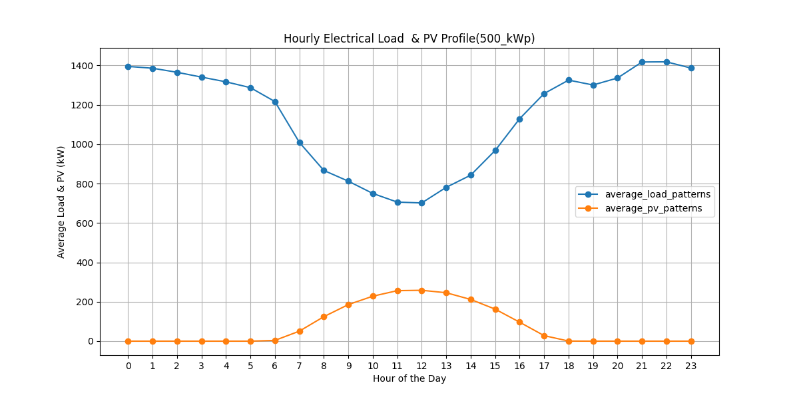

Image: peak_day.png

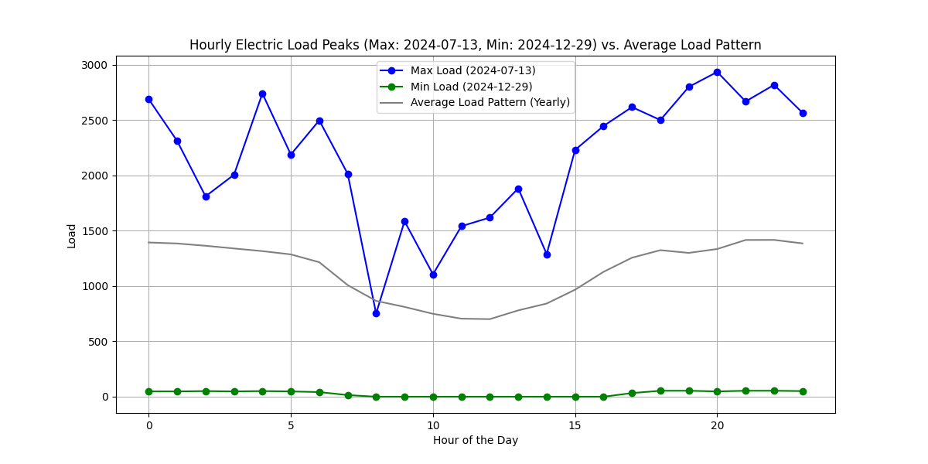

Image: pv curtailed 60 percentile 1,000 kWp.png

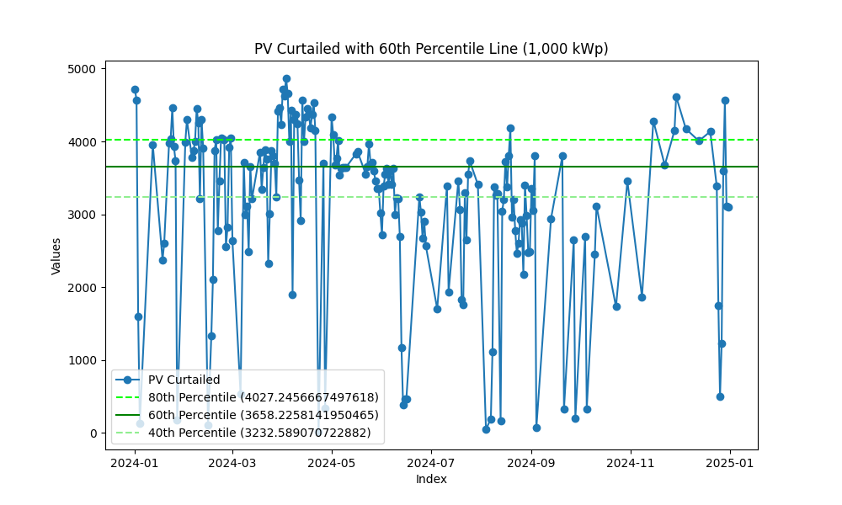

Image: pv curtailed 60 percentile 100 kWp.png

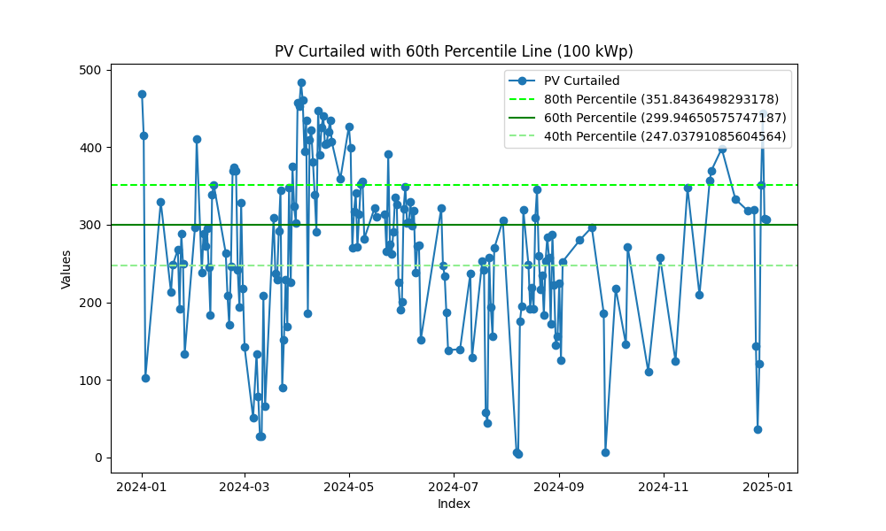

Image: pv curtailed 60 percentile 500 kWp.png

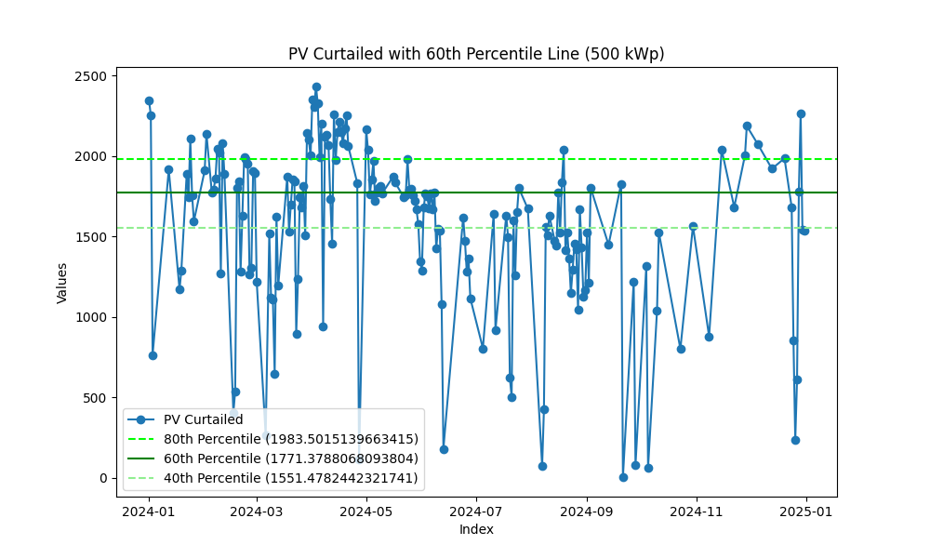

Image: Seasonal.png

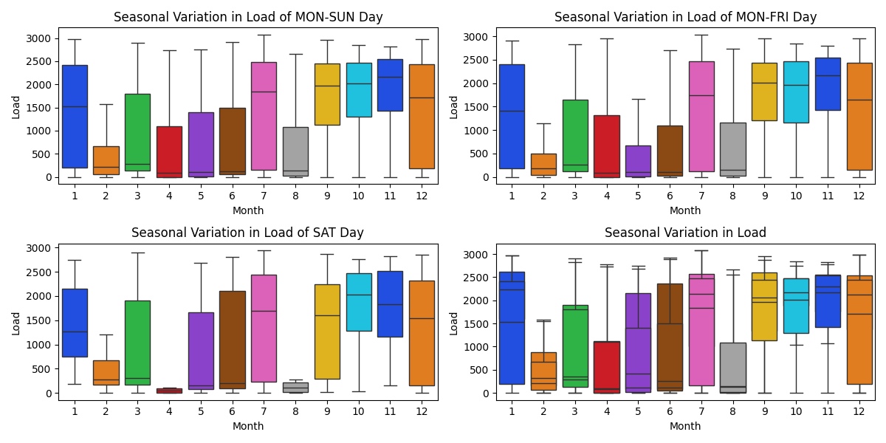

Image: Seasonal_comparison.png

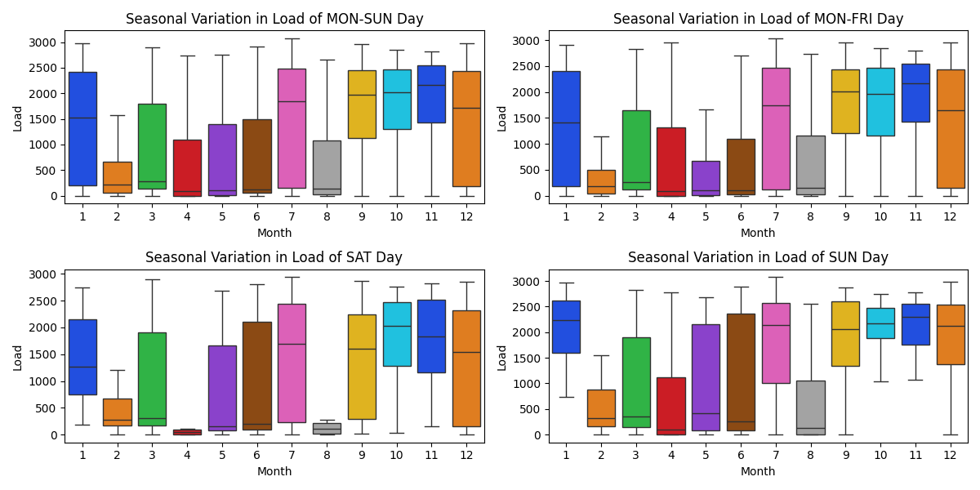

Image: Seasonal_specific_1.png

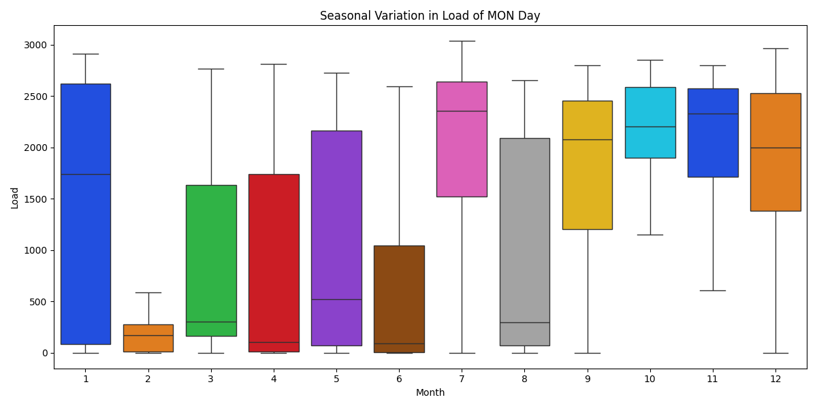

Image: Seasonal_specific_2.png

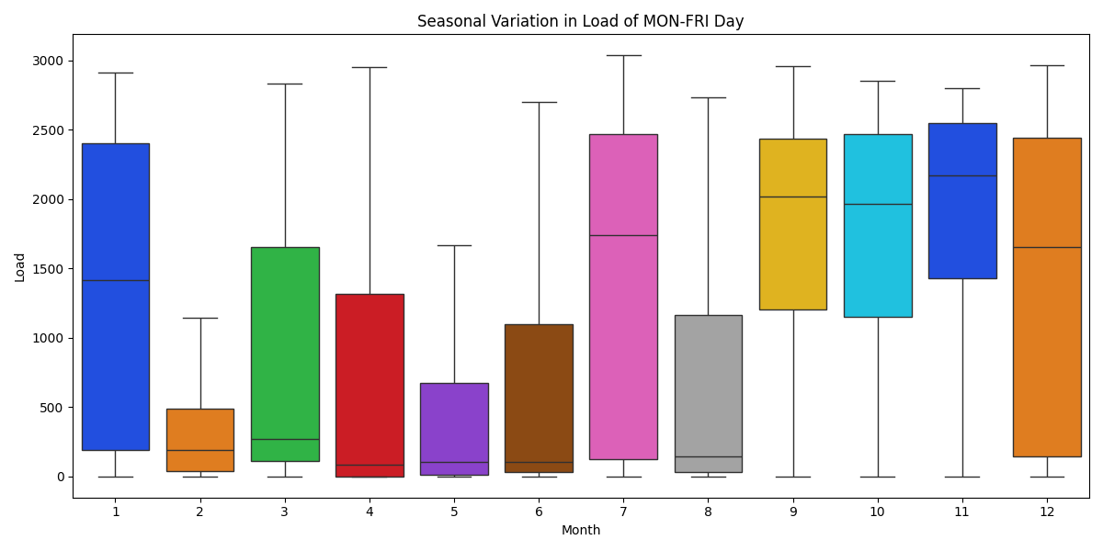

Image: Seasonal_specific_3.png

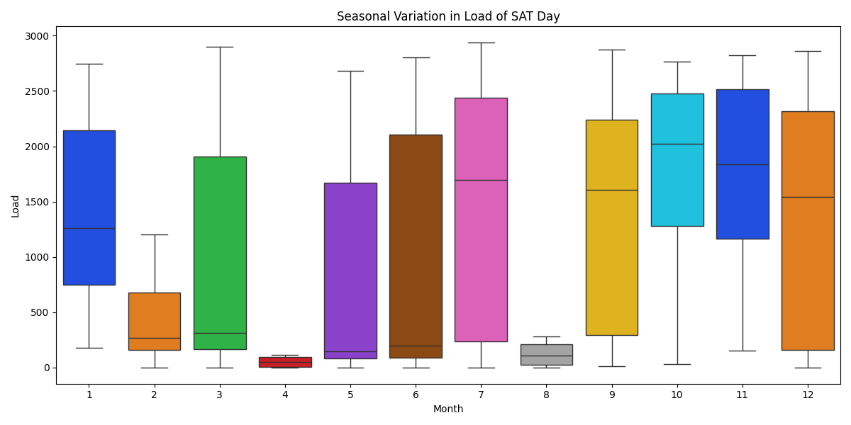

Image: Seasonal_specific_4.png

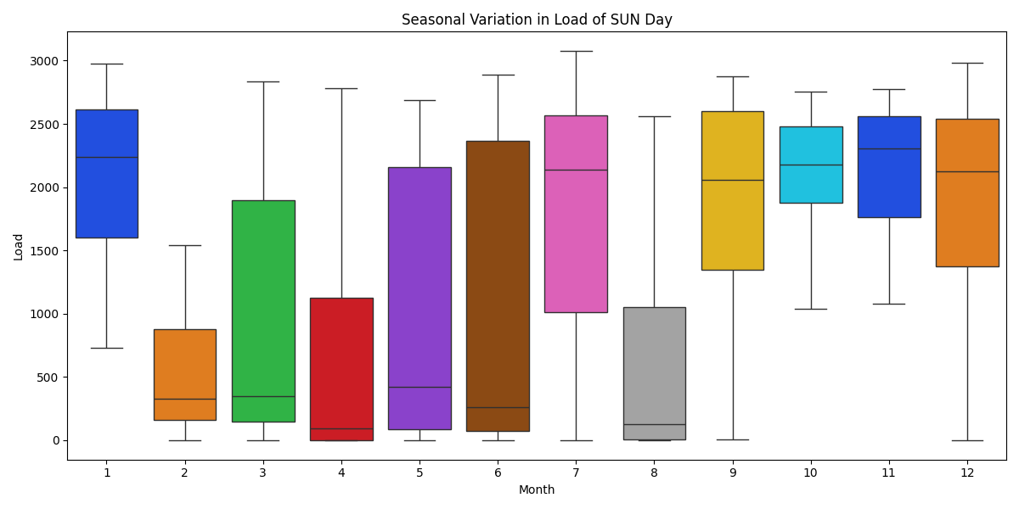

Image: Seasonal_specific_5.png

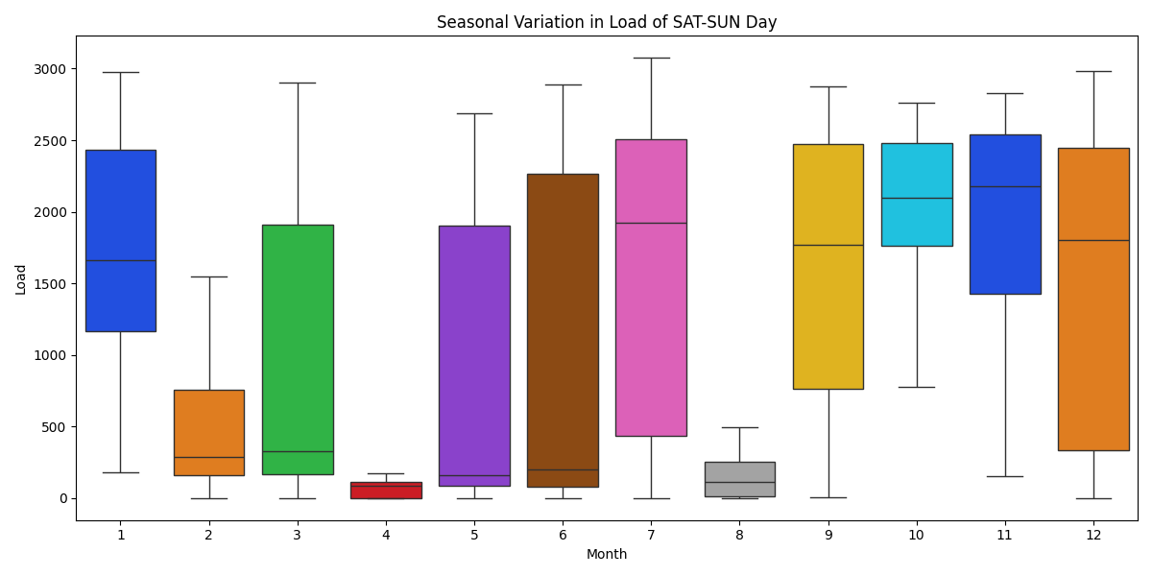

Energy consumption -- Load (kWh)  
1 January: 1,043,178 kWh, Load Factor: 47.2%  
2 February: 384,495 kWh, Load Factor: 20.1%  
3 March: 638,145 kWh, Load Factor: 29.6%  
4 April: 420,387 kWh, Load Factor: 19.8%  
5 May: 489,219 kWh, Load Factor: 23.9%  
6 June: 527,073 kWh, Load Factor: 25.1%  
7 July: 1,103,679 kWh, Load Factor: 48.2%  
8 August: 452,805 kWh, Load Factor: 22.3%  
9 September: 1,208,766 kWh, Load Factor: 56.8%  
10 October: 1,311,042 kWh, Load Factor: 61.8%  
11 November: 1,336,665 kWh, Load Factor: 65.7%  
12 December: 1,080,597 kWh, Load Factor: 48.7%  
  
  
  
Average load factor: 39 %  
  
  
  
Energy of On Peak Data: 3,213,765.00 kWh  
Energy of Off Peak Data: 3,686,394.00 kWh  
Energy of holiday Data: 3,095,892.00 kWh  
Total Energy: 9,996,051.00 kWh  
Sum of all Data: 9,996,051.00 kWh  
Sum of demand_charge: 34,656.00 kW  
  
price_on_peak: 13,446,071.38 THB  
price_off_peak: 17,659,038.06 THB  
price_demand_charge: 4,606,822.08 THB  
Total Electricity Base Price: 35,715,678.40 THB  
 ignore FT & vat  
  
  
On-peak days: 141.9  
Off-peak days: 119.7  
Holiday days: 104.4  
 365 check -> 366.0  
  
  
  
  
PV Install_cap: 100.00 kW  
Energy of pv_produce: 135,513.34 kWh/year (Verify with PVSyst)  
 Monthly average PV energy production (kWh/month): 16,18,18,17,15,13,14,13,14,14,16,16  
Energy of pv_produce: 1,355.13 kWh/kWp/year  
Energy of pv_produce: 3.71 kWh/kWp/day  
Capacity Factor: 15.47 %  
Energy of pv_curtailed: 47,369.43 kWh (34.96 %)  
Energy of pv_serve_load: 88,143.91 kWh  
PR ratio (PV): 0.81  
PR ratio (Load): 0.52  
 pv_serve_load -- On Peak: 51,800.13 kWh  
 pv_serve_load -- Off Peak: 6,757.50 kWh  
 pv_serve_load -- holiday: 29,586.29 kWh  
 CO2 Emission Reduction: 39,841 kg-CO2  
Total Base Price: 416,718.79 THB  
 ignore FT & vat  
  
  
PV < load @9.00: 216 days  
PV > load (in that day): 167 days  
Cycle/year 382 cycles  
5000 Cycle = 13.1 year  
max battery from PV curtailed: 483.92 kWh  
 -- suggest Battery Capacity: 300 kWh  
  
  
 -- installed Battery : 900 kWh  
 -- suggest Battery Saving : 401,587 THB (4,462 THB/kWh/10years)  
 : 42,632 kWh (Curtail 34.96 % -> 3.50 %)  
  
 -- installed Battery : 500 kWh  
 -- suggest Battery Saving : 297,006 THB (5,940 THB/kWh/10years)  
 : 41,106 kWh (Curtail 34.96 % -> 4.62 %)  
  
 -- installed Battery : 400 kWh  
 -- suggest Battery Saving : 257,615 THB (6,440 THB/kWh/10years)  
 : 37,635 kWh (Curtail 34.96 % -> 7.18 %)  
  
 -- installed Battery : 300 kWh  
 -- suggest Battery Saving : 205,005 THB (6,834 THB/kWh/10years)  
 : 31,002 kWh (Curtail 34.96 % -> 12.08 %)  
  
 -- installed Battery : 250 kWh  
 -- suggest Battery Saving : 174,446 THB (6,978 THB/kWh/10years)  
 : 26,655 kWh (Curtail 34.96 % -> 15.29 %)  
  
 -- installed Battery : 200 kWh  
 -- suggest Battery Saving : 141,984 THB (7,099 THB/kWh/10years)  
 : 21,844 kWh (Curtail 34.96 % -> 18.84 %)  
  
 -- installed Battery : 150 kWh  
 -- suggest Battery Saving : 107,780 THB (7,185 THB/kWh/10years)  
 : 16,617 kWh (Curtail 34.96 % -> 22.69 %)  
  
 -- installed Battery : 100 kWh  
 -- suggest Battery Saving : 72,659 THB (7,266 THB/kWh/10years)  
 : 11,208 kWh (Curtail 34.96 % -> 26.68 %)  
  
  
  
  
  
PV Install_cap: 1000.00 kW  
Energy of pv_produce: 1,355,133.39 kWh/year (Verify with PVSyst)  
 Monthly average PV energy production (kWh/month): 161,178,179,172,155,135,136,130,145,138,158,165  
Energy of pv_produce: 1,355.13 kWh/kWp/year  
Energy of pv_produce: 3.71 kWh/kWp/day  
Capacity Factor: 15.47 %  
Energy of pv_curtailed: 612,330.46 kWh (45.19 %)  
Energy of pv_serve_load: 742,802.93 kWh  
PR ratio (PV): 0.81  
PR ratio (Load): 0.44  
 pv_serve_load -- On Peak: 423,890.40 kWh  
 pv_serve_load -- Off Peak: 56,417.65 kWh  
 pv_serve_load -- holiday: 262,494.88 kWh  
 CO2 Emission Reduction: 335,747 kg-CO2  
Total Base Price: 3,614,996.17 THB  
 ignore FT & vat  
  
  
PV < load @9.00: 186 days  
PV > load (in that day): 187 days  
Cycle/year 372 cycles  
5000 Cycle = 13.4 year  
max battery from PV curtailed: 4,866.15 kWh  
 -- suggest Battery Capacity: 3,658 kWh  
  
  
 -- installed Battery : 900 kWh  
 -- suggest Battery Saving : 653,418 THB (7,260 THB/kWh/10years)  
 : 107,540 kWh (Curtail 45.19 % -> 37.25 %)  
  
 -- installed Battery : 500 kWh  
 -- suggest Battery Saving : 369,322 THB (7,386 THB/kWh/10years)  
 : 61,045 kWh (Curtail 45.19 % -> 40.68 %)  
  
 -- installed Battery : 400 kWh  
 -- suggest Battery Saving : 296,541 THB (7,414 THB/kWh/10years)  
 : 49,094 kWh (Curtail 45.19 % -> 41.56 %)  
  
 -- installed Battery : 300 kWh  
 -- suggest Battery Saving : 223,471 THB (7,449 THB/kWh/10years)  
 : 37,073 kWh (Curtail 45.19 % -> 42.45 %)  
  
 -- installed Battery : 250 kWh  
 -- suggest Battery Saving : 186,782 THB (7,471 THB/kWh/10years)  
 : 31,024 kWh (Curtail 45.19 % -> 42.90 %)  
  
 -- installed Battery : 200 kWh  
 -- suggest Battery Saving : 149,776 THB (7,489 THB/kWh/10years)  
 : 24,899 kWh (Curtail 45.19 % -> 43.35 %)  
  
 -- installed Battery : 150 kWh  
 -- suggest Battery Saving : 112,617 THB (7,508 THB/kWh/10years)  
 : 18,736 kWh (Curtail 45.19 % -> 43.80 %)  
  
 -- installed Battery : 100 kWh  
 -- suggest Battery Saving : 75,298 THB (7,530 THB/kWh/10years)  
 : 12,534 kWh (Curtail 45.19 % -> 44.26 %)  
  
  
  
  
  
PV Install_cap: 500.00 kW  
Energy of pv_produce: 677,566.69 kWh/year (Verify with PVSyst)  
 Monthly average PV energy production (kWh/month): 81,89,90,86,77,67,68,65,72,69,79,82  
Energy of pv_produce: 1,355.13 kWh/kWp/year  
Energy of pv_produce: 3.71 kWh/kWp/day  
Capacity Factor: 15.47 %  
Energy of pv_curtailed: 288,514.38 kWh (42.58 %)  
Energy of pv_serve_load: 389,052.31 kWh  
PR ratio (PV): 0.81  
PR ratio (Load): 0.46  
 pv_serve_load -- On Peak: 222,476.52 kWh  
 pv_serve_load -- Off Peak: 29,757.06 kWh  
 pv_serve_load -- holiday: 136,818.73 kWh  
 CO2 Emission Reduction: 175,852 kg-CO2  
Total Base Price: 1,871,970.63 THB  
 ignore FT & vat  
  
  
PV < load @9.00: 199 days  
PV > load (in that day): 175 days  
Cycle/year 373 cycles  
5000 Cycle = 13.4 year  
max battery from PV curtailed: 2,431.58 kWh  
 -- suggest Battery Capacity: 1,771 kWh  
  
  
 -- installed Battery : 900 kWh  
 -- suggest Battery Saving : 641,634 THB (7,129 THB/kWh/10years)  
 : 103,140 kWh (Curtail 42.58 % -> 27.36 %)  
  
 -- installed Battery : 500 kWh  
 -- suggest Battery Saving : 361,617 THB (7,232 THB/kWh/10years)  
 : 58,101 kWh (Curtail 42.58 % -> 34.01 %)  
  
 -- installed Battery : 400 kWh  
 -- suggest Battery Saving : 290,555 THB (7,264 THB/kWh/10years)  
 : 46,665 kWh (Curtail 42.58 % -> 35.69 %)  
  
 -- installed Battery : 300 kWh  
 -- suggest Battery Saving : 219,120 THB (7,304 THB/kWh/10years)  
 : 35,166 kWh (Curtail 42.58 % -> 37.39 %)  
  
 -- installed Battery : 250 kWh  
 -- suggest Battery Saving : 183,077 THB (7,323 THB/kWh/10years)  
 : 29,382 kWh (Curtail 42.58 % -> 38.24 %)  
  
 -- installed Battery : 200 kWh  
 -- suggest Battery Saving : 146,824 THB (7,341 THB/kWh/10years)  
 : 23,567 kWh (Curtail 42.58 % -> 39.10 %)  
  
 -- installed Battery : 150 kWh  
 -- suggest Battery Saving : 110,482 THB (7,365 THB/kWh/10years)  
 : 17,746 kWh (Curtail 42.58 % -> 39.96 %)  
  
 -- installed Battery : 100 kWh  
 -- suggest Battery Saving : 73,990 THB (7,399 THB/kWh/10years)  
 : 11,888 kWh (Curtail 42.58 % -> 40.83 %)

## Images from EPC

Image: Annual Revenue and O&M Cost 100 kW.png

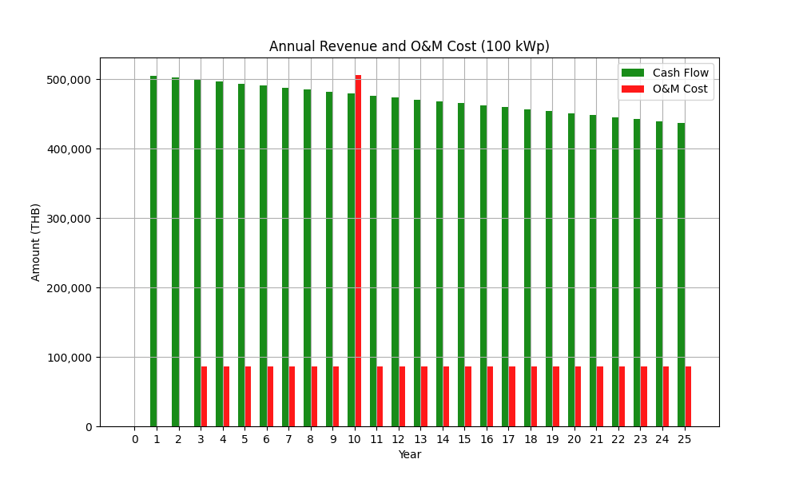

Image: Annual Revenue and O&M Cost 1000 kW.png

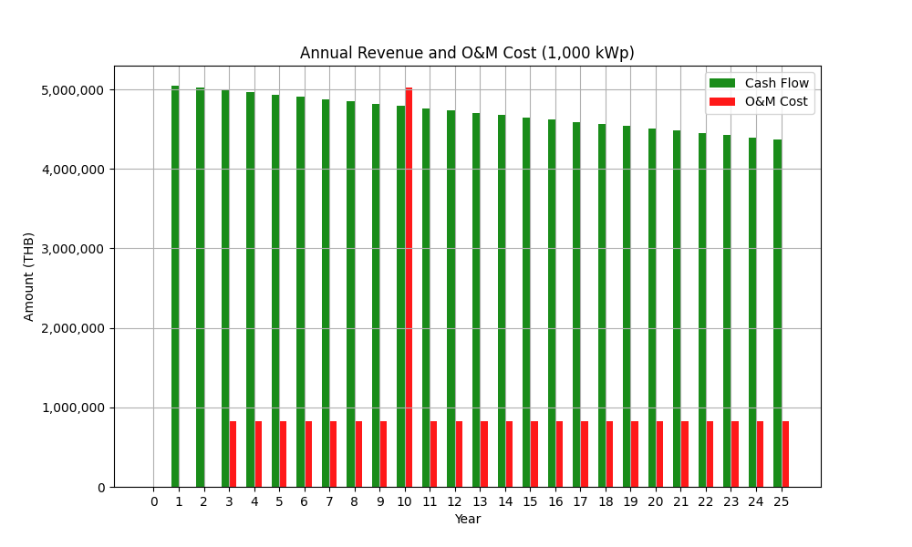

Image: Annual Revenue and O&M Cost 500 kW.png

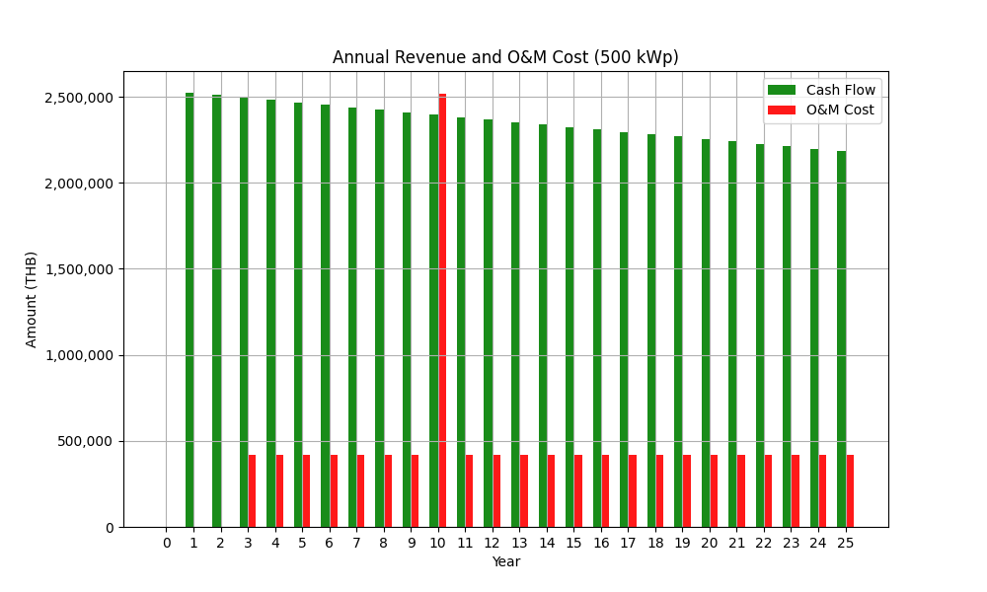

Image: Cumulative Cash Flow 100 kW.png

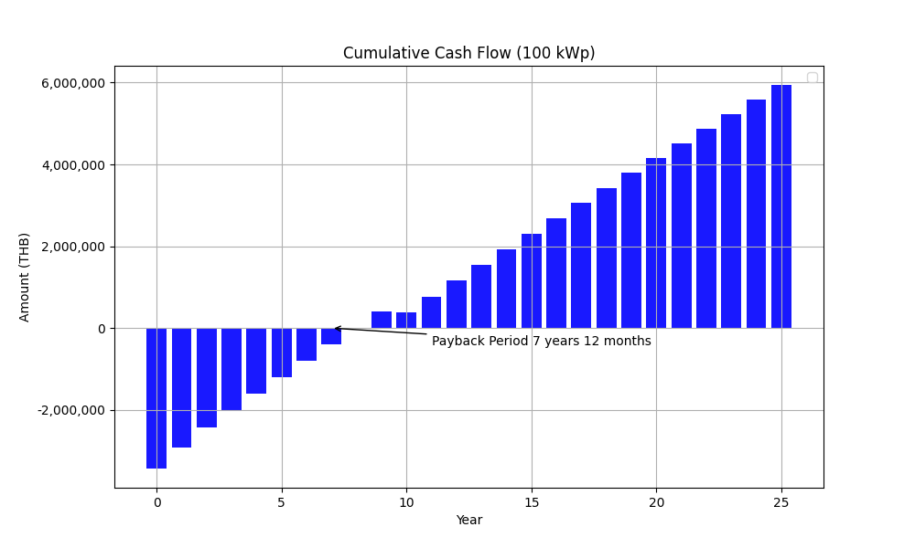

Image: Cumulative Cash Flow 1000 kW.png

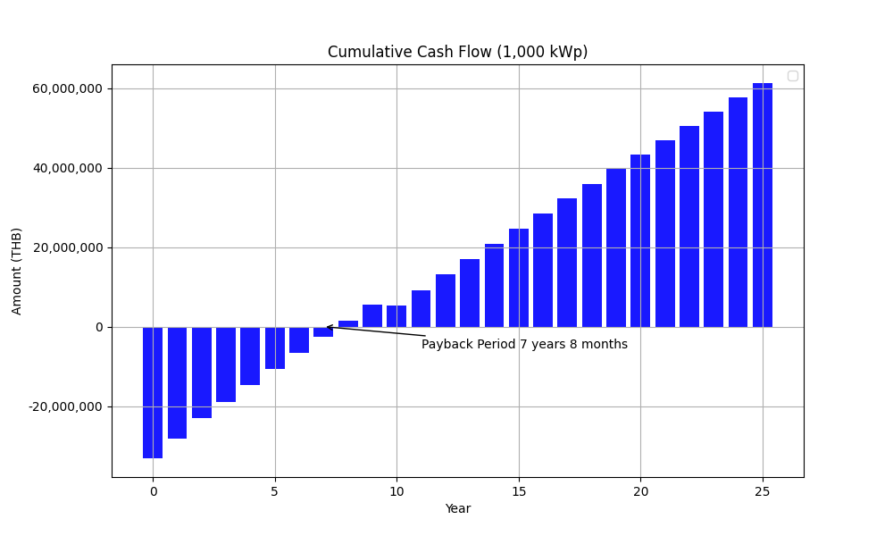

Image: Cumulative Cash Flow 500 kW.png

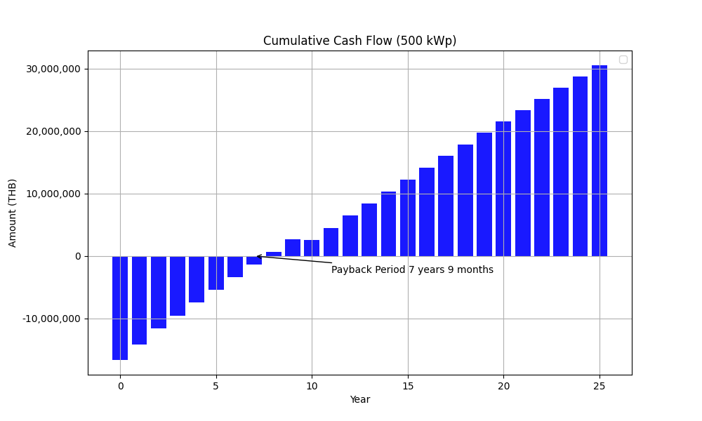

Image: Economic Indicators for Solar PV Project 100 kW.png

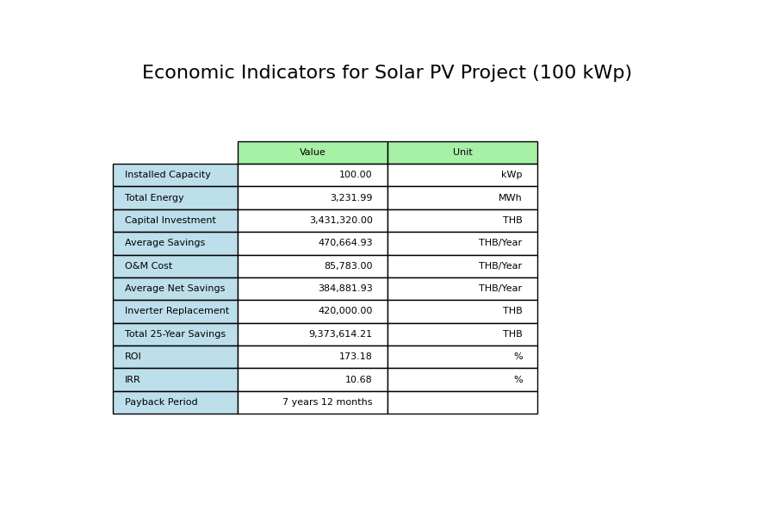

Image: Economic Indicators for Solar PV Project 1000 kW.png

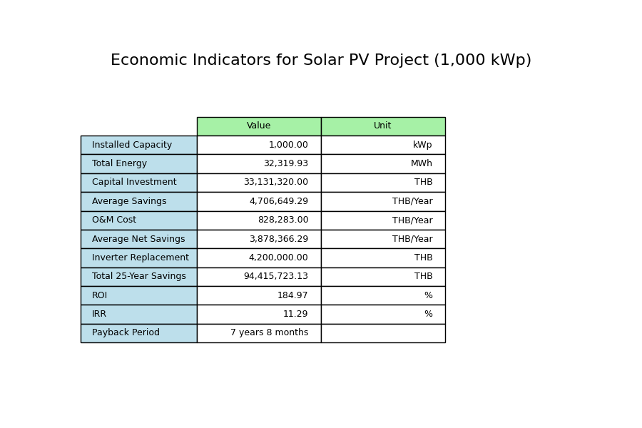

Image: Economic Indicators for Solar PV Project 500 kW.png

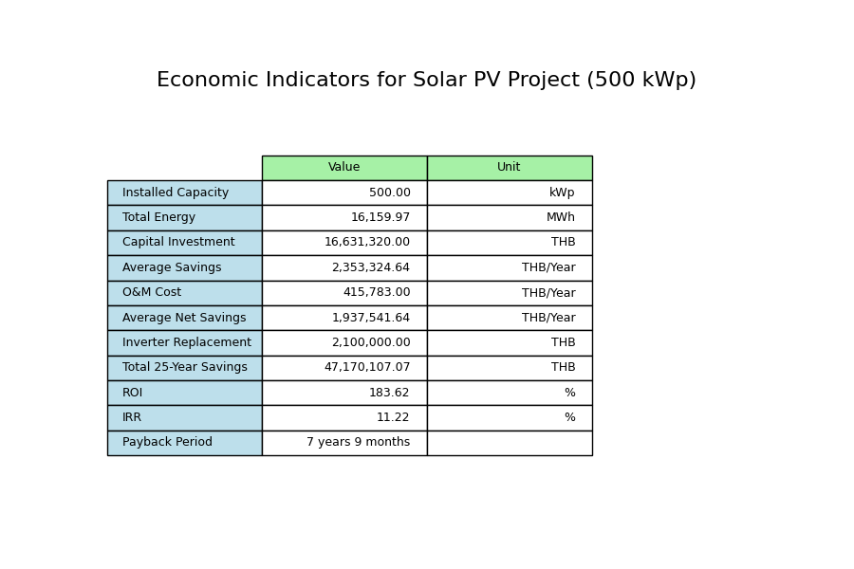

Assumption EPC:  
Tariff Rate Average (with VAT): 3.80000 THB/units  
  
Inputs Configuration:  
Project Time (Years): 25 years  
Cost per kW: 30000.0 THB/kW  
Margin: 10.0 %  
Sale Price per kW: 33000.00 THB/kW  
Solar Degradation First Year: 2.0 %  
Solar Degradation After First Year: 0.55 %  
Inverter Replacement Cost: 4200 THB/kW  
O&M Percentage: 2.5 %  
O&M Escalation Rate: 0.0 %  
O&M Starts at Year: 3  
  
EGAT Operation Cost:  
General Work Cost: 127000 THB  
Distance from EGAT HQ: 160 km  
EGAT Operation Cost: 131320 THB

## Images from GSA

Image: Electricity Cost Comparison 1,000kWp_15.0_15yr.png

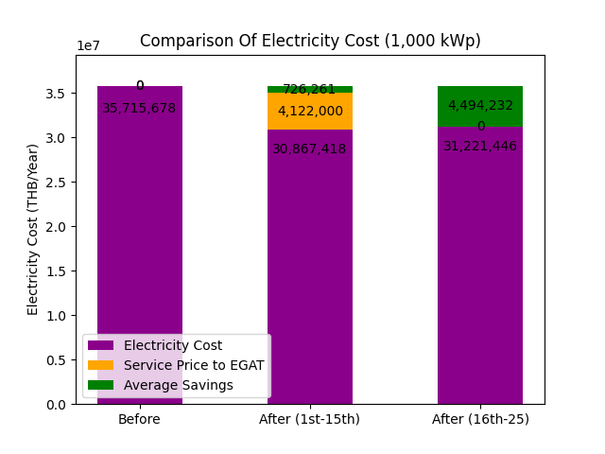

Image: Electricity Cost Comparison 100kWp_15.0_15yr.png

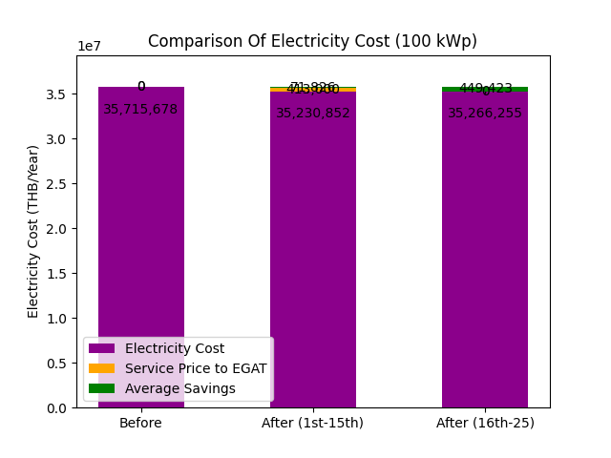

Image: Electricity Cost Comparison 500kWp_15.0_15yr.png

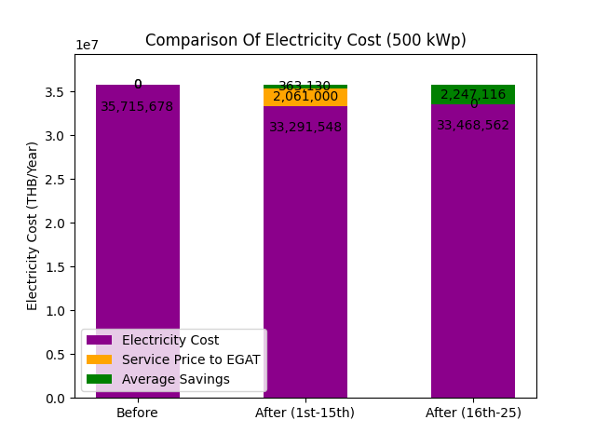

Image: Table image 1,000 kWp 15.0_15 yr.png

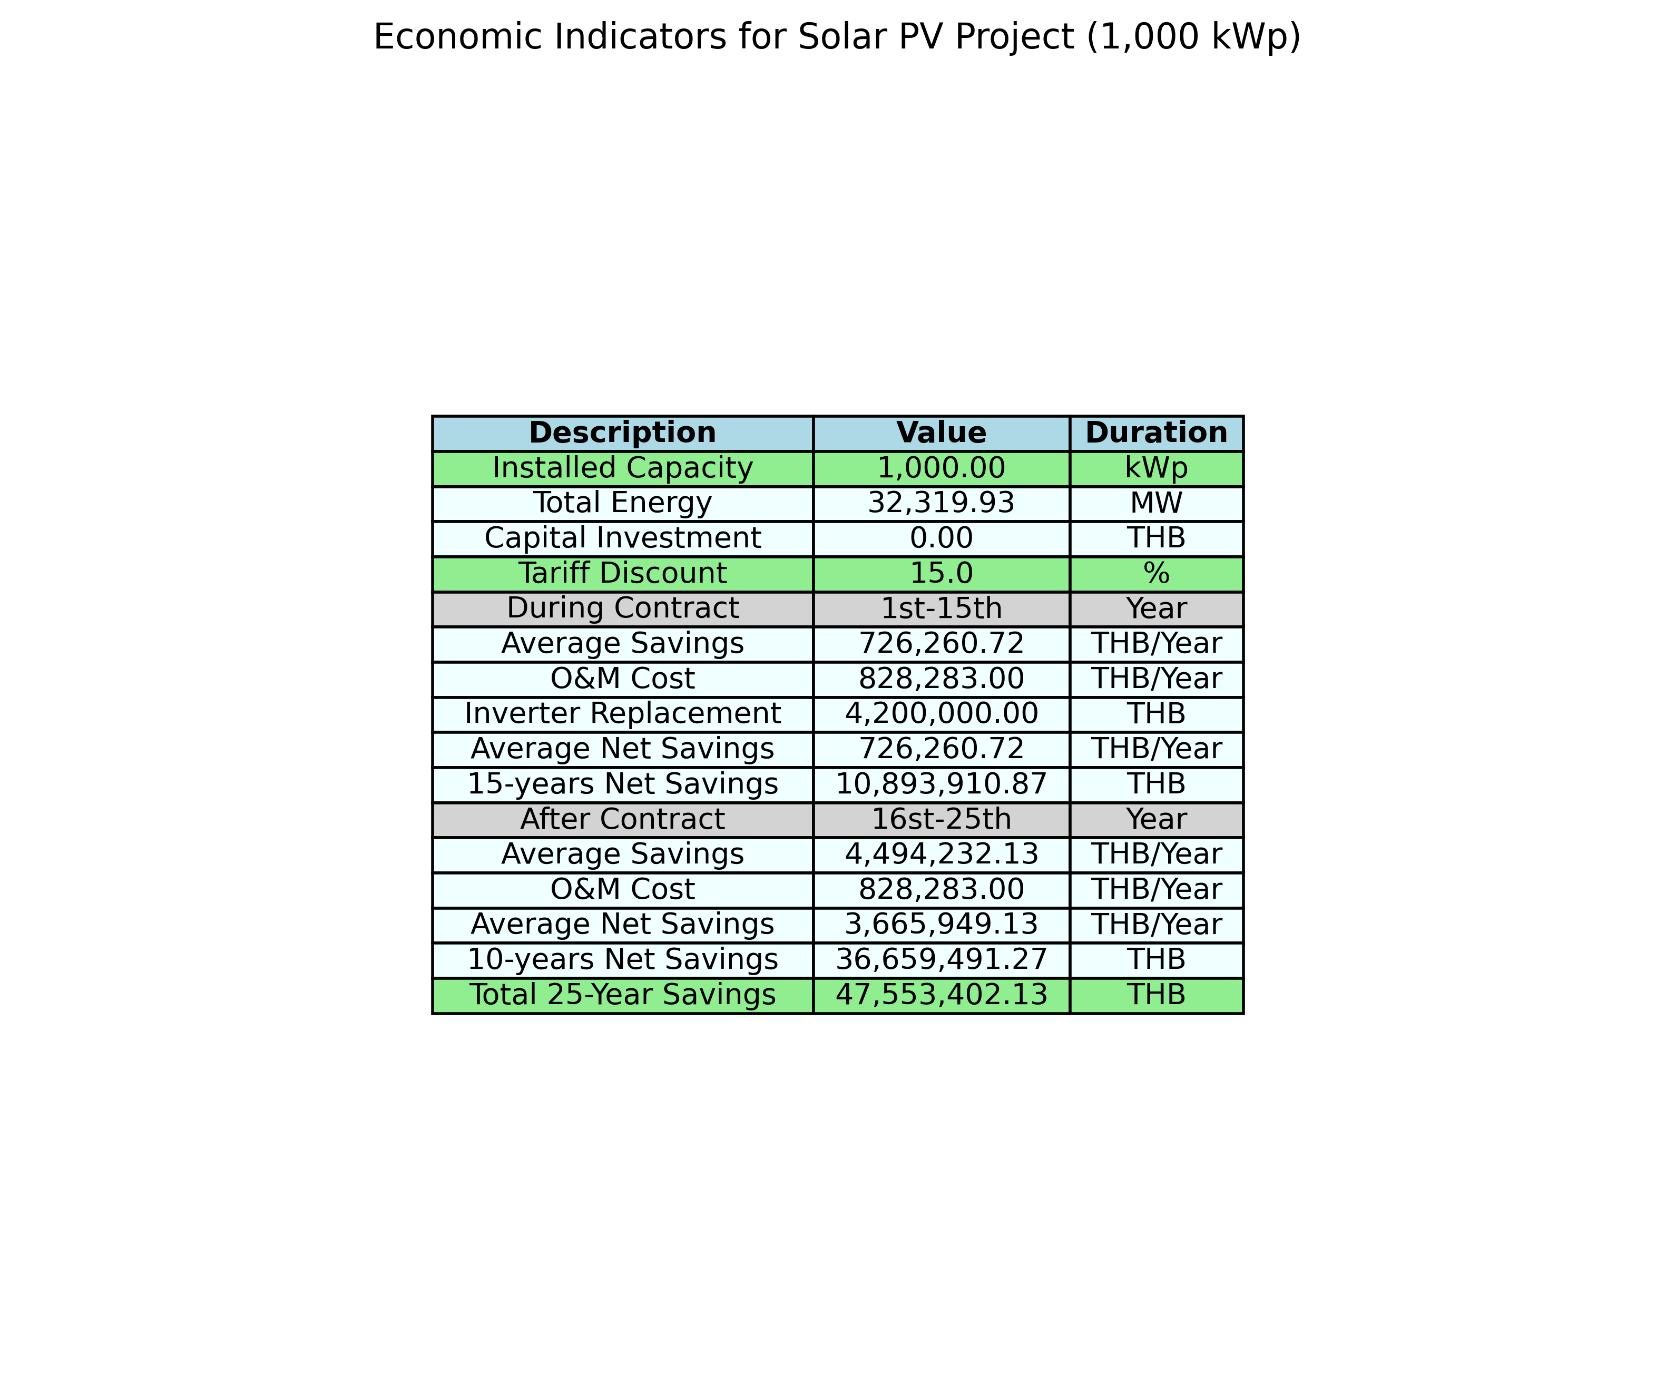

Image: Table image 100 kWp 15.0_15 yr.png

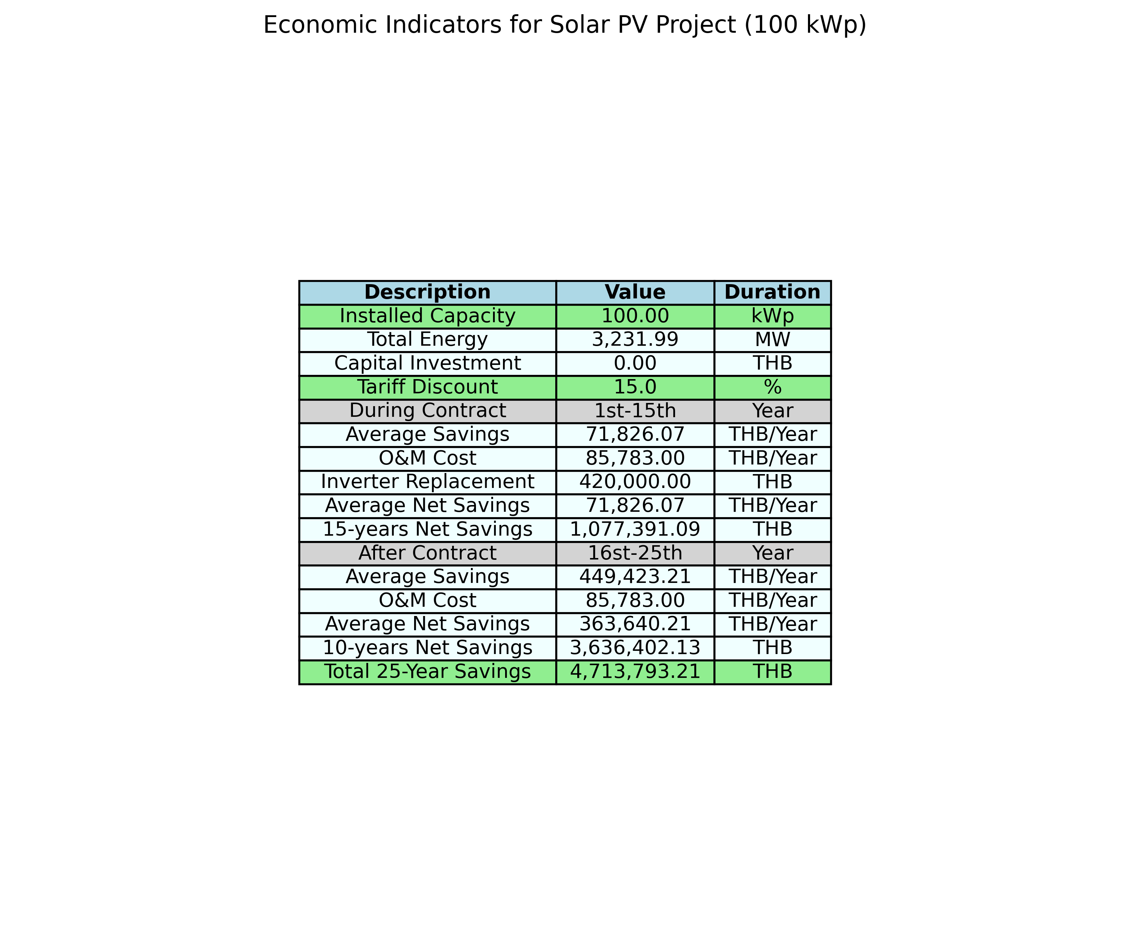

Image: Table image 500 kWp 15.0_15 yr.png

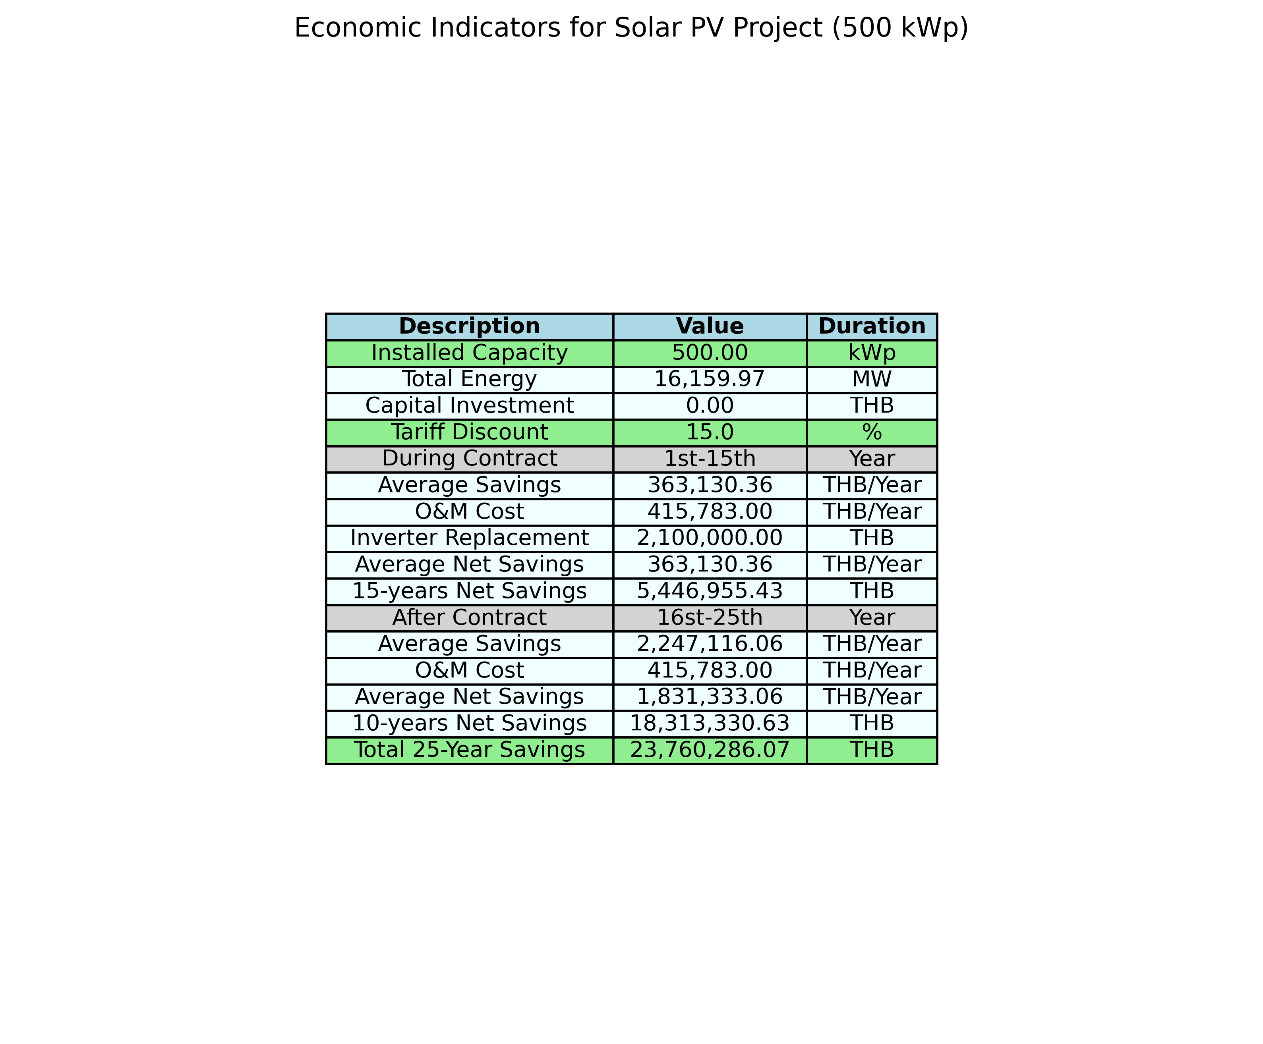

Assumption GSA:  
Tariff Rate Average (with VAT): 3.80000 THB/units  
  
Inputs Configuration:  
Project Time (Years): 25 years  
Cost per kW: 30000.0 THB/kW  
Margin: 10.0 %  
Sale Price per kW: 33000.00 THB/kW  
Solar Degradation First Year: 2.0 %  
Solar Degradation After First Year: 0.55 %  
Inverter Replacement Cost: 4200 THB/kW  
O&M Percentage: 2.5 %  
O&M Escalation Rate: 0.0 %  
O&M Starts at Year: 3  
  
tariff discount: 15.0 % (include FT, exclude VAT)  
contract year = 15 year  
  
EGAT Operation Cost:  
General Work Cost: 127000 THB  
Distance from EGAT HQ: 160 km  
EGAT Operation Cost: 131320 THB